**Architecting Sustainable Applications***Designing Apps Using an Architecture Framework*  
Why is Architecture Important?  
  
Welcome!

In this lesson, we will explain why it is important to design a good application architecture.

To get there, we will talk about what building quality software means and explore the typical issues that surface when architectural concerns are lacking.

Why is application architecture important when building quality software solutions?

If we go back to 1991, the International Standards Organization (ISO), and the International Electrotechnical Commission (IEC), put together a standard on the quality of software solutions.

This standard included several different dimensions.

Usability from the point of view of the users.

Functionality as a set of functions that satisfy needs.

Efficiency, which relates the performance to the amount of resources used.

Maintainability, which relates to the effort needed to make modifications.

Portability, which defines the ability to move software between environments.

And Reliability, which ensures that a software solution can maintain its performance over a period of time.

Later on, in 2011, the standard was updated.

Security was added to ensure that software solutions can protect information and data.

Compatibility was also added as a way to ensure that a piece of software can work together with other systems.

Building quality software is important, and all of these dimensions are quite relevant.

Having a well-defined software architecture allows you to think ahead in all of these dimensions.

So what are some of the typical issues that arise due to a lack of architectural concerns?

When services for core business concepts are not correctly isolated and abstracted, less code reuse exists, and business rules tend to be spread all over the place.

Dependencies between systems that are not correctly isolated become unmanageable.

Updating or replacing a system has a snowball effect on the remaining parts.

When we change one thing in the code, another part breaks.

Legacy systems tend to take longer to change and adapt to the different needs and requirements.

Sometimes the technology is obsolete, and the core information accumulated can obstruct its replacement.

Without a good plan and well-defined application architecture, you can end up with what we might call a "Spaghetti Architecture."

Such systems can hinder future changes as they become less flexible and much more difficult to manage.

One small change in one component often creates a series of complex, cascading effects on the other components.

Sometimes this is also known as 'tightly coupled architecture,' or 'brittle architecture.'

So, why is architecture important?

If you spend time thinking about and discussing architecture, it will increase awareness and understanding of the solution.

It also helps create common ground among all the people and teams that are involved.

The project complexity becomes more evident as the different systems get represented.

An appropriate level of abstraction in modeling helps to reduce the emerging complexity by focusing on the relevant properties and omitting irrelevant detail, thus leading to a simpler representation.

By managing the complexity, you may actually reduce the overall risk.

We need to evaluate a system's architecture for its capacity to support the quality attributes that meet the organization's goals.

Architecture evaluation is a cost-effective way of mitigating substantial risks and ensuring success.

Thinking about the complexity and the risks will help you support planning.

This way, you will do a better job anticipating and building solutions that will be better understood.

As you are going through the building process, it can also facilitate change.

When something comes up that requires you to veer from the original design or path, the architecture of your system can show you exactly what needs to change and help with communication and planning.

Finally, all these benefits can help you reduce the overall cost of your project.

As you can see, spending time thinking about architecture can provide a lot of different benefits.

These benefits are not only technical, they also affect how you operate, and the overall visibility of how you build things.

In the next lesson, we will introduce you to the OutSystems Architecture Canvas.

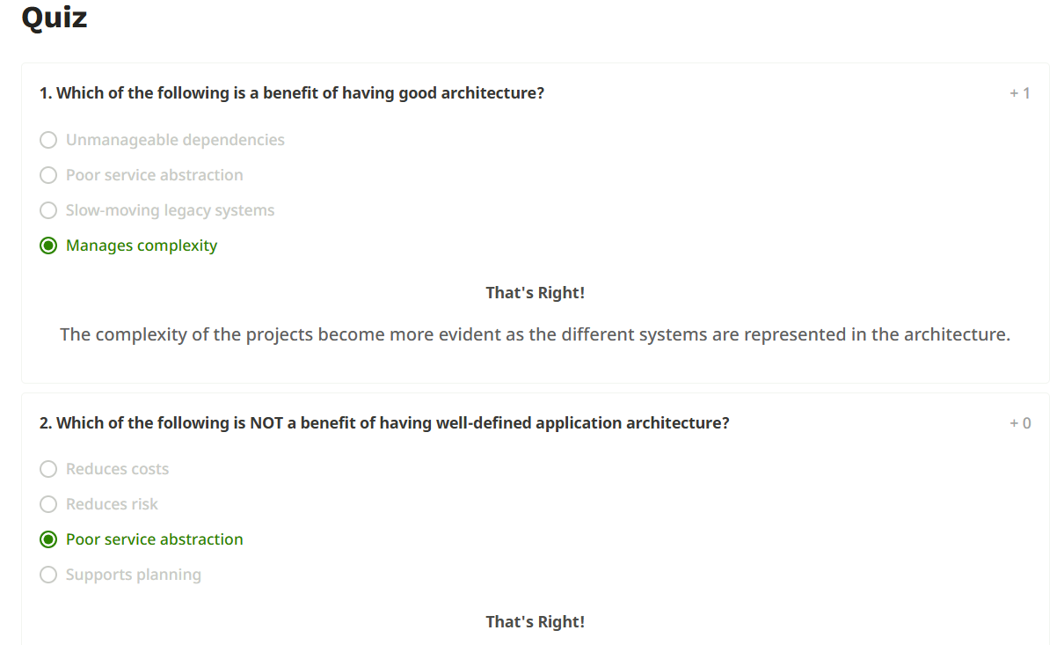  
 *OutSystems Architecture Framework*  
The Architecture Canvas  
  
In this lesson, we'll introduce you to the OutSystems Architecture Canvas.

We'll start the session by discussing what it is, and then cover why it is important.

By the end, we'll see how the canvas fits in an enterprise ecosystem.

Starting with the what ...

The Architecture Canvas is the adopted framework to design application architecture in OutSystems.

It provides a systematic approach to speed up architecture design.

It is a multi-layer framework, composed of three layers.

Foundation,  
Core,  
and End-user.

The two bottom layers are where all the reusable services will be isolated and mapped in this framework.

More specifically, the Foundation layer contains all reusable, non-functional, business-agnostic Modules such as connectors to external systems, libraries, reusable UI patterns, and themes.

In this layer, you should not have any business-specific services.

In the Core layer we will implement core business services.

These include the services around business concepts such as their dependencies and business rules.

These core business services should be system agnostic and abstract integration details from the underlying foundation services.

Finally, at the top you have the end-user layer that should not have any services.

Here, you will support all your user interactions through user interfaces and processes.  
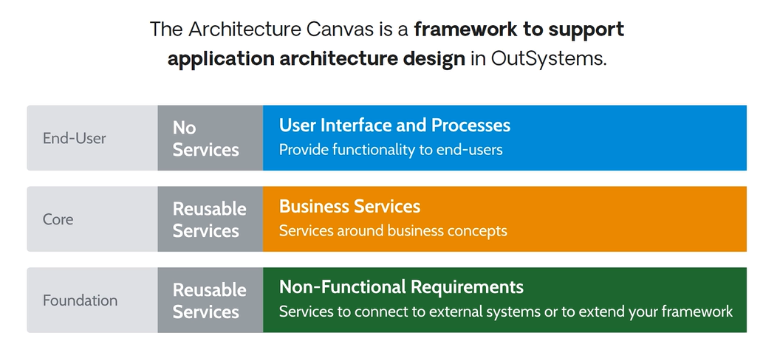

Now, let's see why you should use the Architecture Canvas.

It promotes the correct abstraction of reusable services and components.

Understanding and having a clear definition of the dependencies among all parts helps optimize lifecycle independence.

Finally, it helps you minimize the impact of changes.

This leads to easier maintenance and more efficient application evolution.  
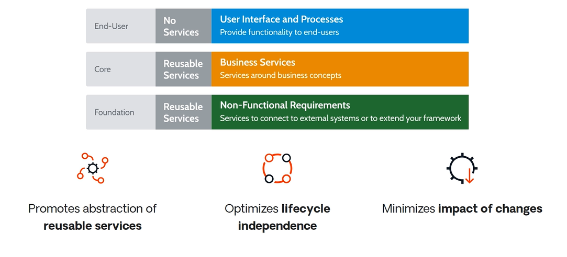

Now, let's see how the Architecture Canvas and your application architecture work side by side in your enterprise ecosystem.

OutSystems is one more technology in your IT ecosystem.

So you'll probably need to integrate it with other existing in-house or cloud-based systems.

To achieve that level of integration, you can have integration services, which are merely technical wrappers to external producers.

The main goal of these services is to normalize data structures and abstract integration complexity, like error handling and authentication.

Remember that the Foundation layer is where non-functional requirements are defined, which are business agnostic and may be reused across any business domain.

The Core layer, in addition to the core services, will contain all the business rules, transactions, and data.

You may also have APIs to be consumed by external systems.

These interfaces define interactions between the internal core services and external consumers using REST, SOAP, or any other type of API.

Finally, the applications in the end-user layer will serve both intranet and extranet users.

Now you know the Architecture Canvas, why it is important, and how it helps build application architecture in OutSystems.

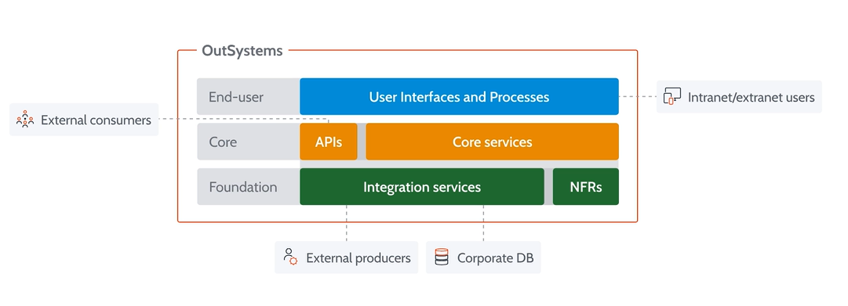  
The Architecture Design Process  
  
In this lesson, you will be introduced to the architecture design process.

This three-step process will help you design your application architecture.

It is fundamental to align your architecture with your business goals.

Business must orient architecture, so business needs and concepts should be properly translated into Modules.

This strategy allows the Modules to evolve and scale with business, while ensuring independent lifecycles between different lines of business.  
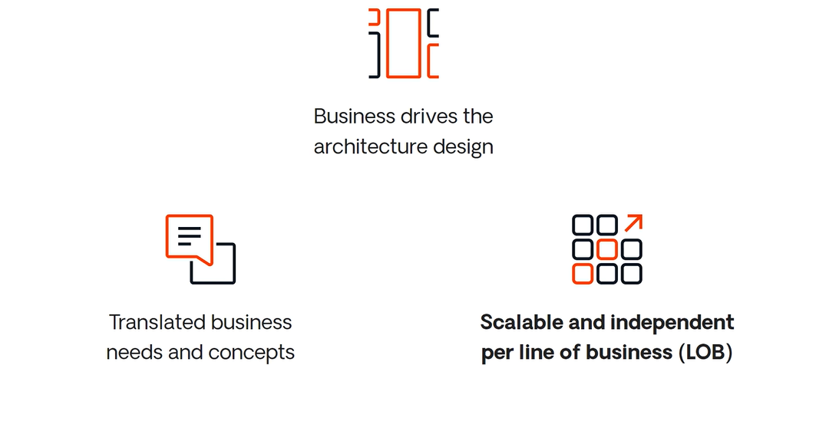

The three steps for architecture design are Disclose, Organize, and Assemble.

The first step is where business concepts, integration needs, and non-functional requirements are disclosed.

Identifying relevant user stories can achieve this disclosure.

Understanding who will interact or access the application, what the roles are, and the kind of different actions each person can perform are also important questions to answer.

Analyzing existing documentation, or simply by having a conversation with business stakeholders will also add valuable context.

The information architecture as recognized by the business users.

Either talking with the users or analyzing an existing system that you are going to augment or replace will help you get a clear view of the information architecture.

We need to understand the integration technology that will be involved in the project.

So it's important to disclose what information will be consumed from external sources or systems.

It is also important to disclose the needed integrations.

The type of API, communication protocol, I/O structure, message headers, and others.

User experience is another key factor.

Will accessibility be a requirement?

What types of channels are planned?

Is this a mobile-only app, or also a web app?

Different roles might use or require different channels, which results in a different user experience.

It is important to disclose as many concepts from the beginning as possible.

As the project moves forward, you might end up disclosing more concepts and finding more details.

Missing major concepts at the beginning might compromise the future of your applications, leading to complex refactoring later on.  
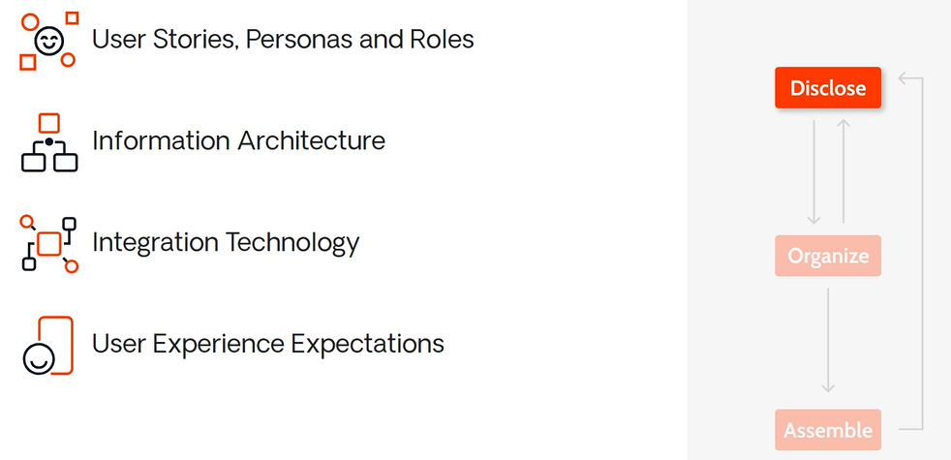

From the Disclose step, we move to Organize.

Here, concepts will be added to the layers of the Architecture Canvas.

As you start organizing concepts, you can actually disclose some more concepts.

In the end, both Disclose and Organize work in tandem and require a bit of iteration.

Interface-related concepts and processes are placed at the end-user layer.

Core business concepts end up in the core layer.

While integration needs and non-functional requirements should be placed in the foundation layer.

Keep in mind that during the Disclose and Organize steps, we are still talking about concepts, not Modules nor application artifacts.  
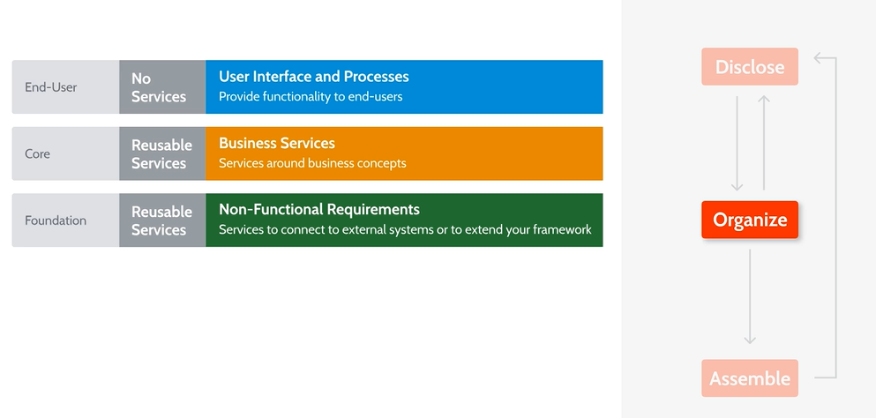

The third and final step is where concepts are assembled into Modules.

In this step, you should follow a few principles.

The concepts that relate to others should be joined.

For instance, if the concepts Customer and Claim are related, they should be joined into the same Module.

However, concepts with different lifecycles should be split into different Modules, even if they are related.

For example, the Customer and Contract concepts can be related, but if you realize that some of the customers don't have a contract, it means they have different lifecycles and therefore shouldn't be joined.

The third principle says to isolate reusable logic from integration logic.

Reusable logic should be isolated in the core layer, while integration logic ends up in the foundation layer.

This protects the reusable core logic from external system changes by keeping them independent from each other.

Finally, when possible, you should apply known architectural design patterns.

In the beginning, this may not be 100% clear, but as you move on you'll get to know more patterns and define a better and more robust architecture.  
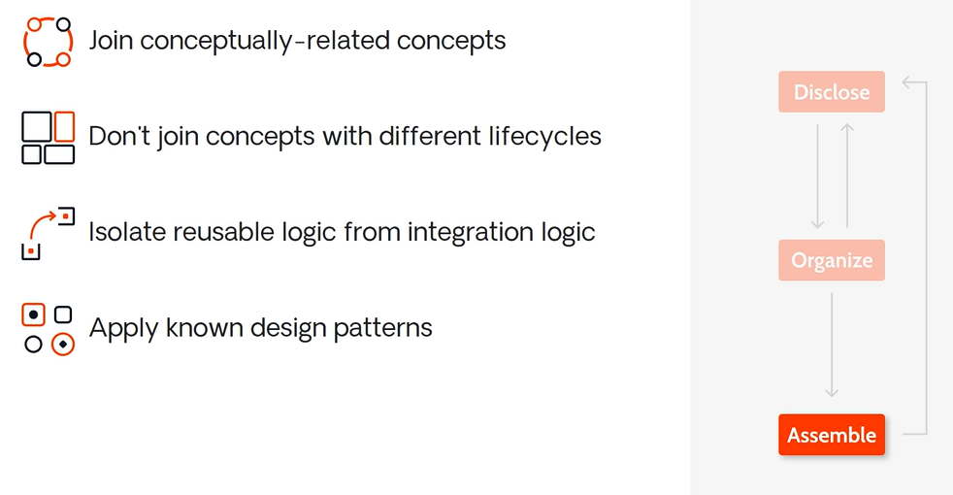

Once you complete the process, you end up with an "architecture blueprint."

The blueprint shows each Module in the corresponding layer.

From there, you should now add the dependencies between Modules.

Doing so gives you an initial idea of what they need and how each Module relates to the others.

During the project, you need to keep iterating the three steps of the process.

As you disclose new concepts, you need to organize them and assemble them into the canvas.

In the next lesson, we'll put this process into practice.  
  
Desinging an Architecture (With the example)  
  
In this lesson, we are going to apply the architecture design process in a specific business case: a Doctor’s Appointments app.

After following the three steps of the design process, we will get to the architecture blueprint and reference map.

We will follow the architecture design process for a hospital-related app.

This app enables the managing of hospital doctors' appointments.

In total, we have five requirements listed here.

We'll go by each one of these as we build up our Architecture Canvas.

We will start with an empty Architecture Canvas by the Disclose step.

Starting by the first requirement, you'll need to identify the end-user processes that need to be supported.

In this case, doctors need to see their agenda and their patients' exams, and to be able to select urgent cases.

Since these are user process concepts, they should be organized in the end-user layer.

Here, we are placing concepts into the correct layers as we identify them.

This is actually part of the Organize step in the design process.

The "Doctor" represents a core business concept that will have to be mapped in your system.

So the "Doctor" concept should be part of the core layer.

It is also possible to identify the "exam" concept, and to relate each exam to a patient.

So both these concepts should be taken into account.

They too belong to the core layer.

Moving on to the second requirement: Doctors work in different units from different hospitals.

Besides doctors, which are already represented, we can identify two more concepts: Units and Hospitals.

Once again, these are organized in the core layer.

The third requirement allows us to expand our canvas a bit more.

From it, we learn that Google Calendar is used to represent the appointments and find the doctors' availability.

The "Appointment" core business concept can be identified.

It is actually based on other core concepts.

An appointment will occur at a given hospital, with a specific doctor, and a certain patient.

It should also have a time slot, along with some additional information that will be represented inside the appointment.

The application will need to interact with Google Calendar to represent appointments and to find the doctors' availability.

Since this is an integration with an external system, it should be part of the foundation layer.

This is where integrations belong.

Regarding the fourth requirement, we can extract that doctors will be notified.

This will happen via text message (SMS) or push notification when they are online.

This result can be achieved with external systems; therefore, these should also be part of the foundation layer.

Finally, requirement five tells us about a web application to manage appointments.

In this case, you have one more end-user layer concept.

For now, the Disclose and Organize steps should be over.  
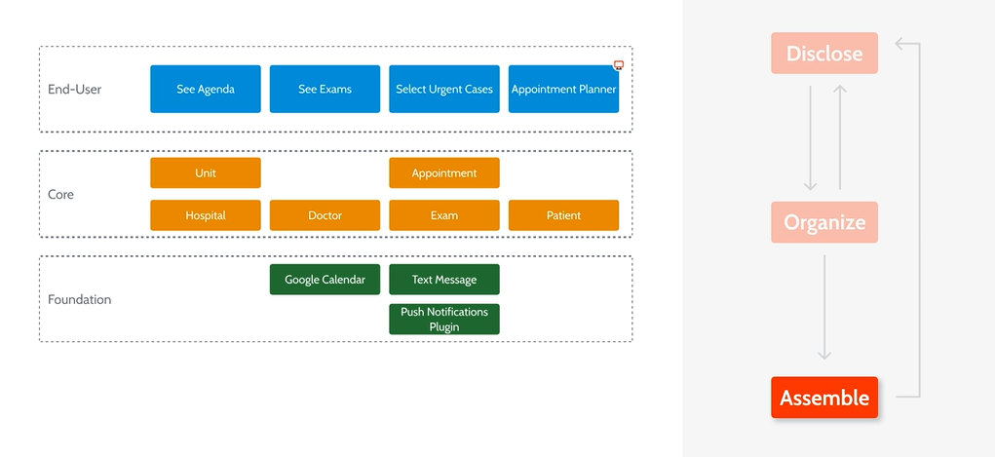

Next in the process is going over the Assemble step.

So let's think about how these concepts translate into Modules.

First, looking at the doctor processes, they can live together in the same mobile Module because you don't need to have separate lifecycles for these processes.

So you assemble these three concepts into the Doctor Mobile app.

The "Exam" concept should live in its own Module.

The same thing happens with the "Doctor" concept.

And the Patient concept.

Here's an example where you can merge two concepts into a single Module.

Since units are related to hospitals, it makes no sense to deal with units without hospitals.

So these two will become the Hospital Module.

"Appointment" should be a Module orchestrating the other core Modules.

Given that you want to create a mobile application, we will also need local storage.

For that reason, you should also create a specific Module to handle the local data and synchronization of information between the mobile device and the server.

For both the Doctor mobile and Appointment Planner web app, Widgets or blocks will be needed.

It is a good practice to isolate those elements into specific Modules.

Google Calendar provides the functionality to access the calendar.

Text Messages and Push Notification Modules provide access to features so that doctors can be notified.

These should be done through integration Modules on the server-side, so web and mobile applications can also reuse them.

Finally, you can have different themes — one for the planner web application and another for the doctor mobile application.

These are all the Modules that have been identified during the architecture design process.

We call this the architecture blueprint, and it shows all Modules in their specific layers.  
  
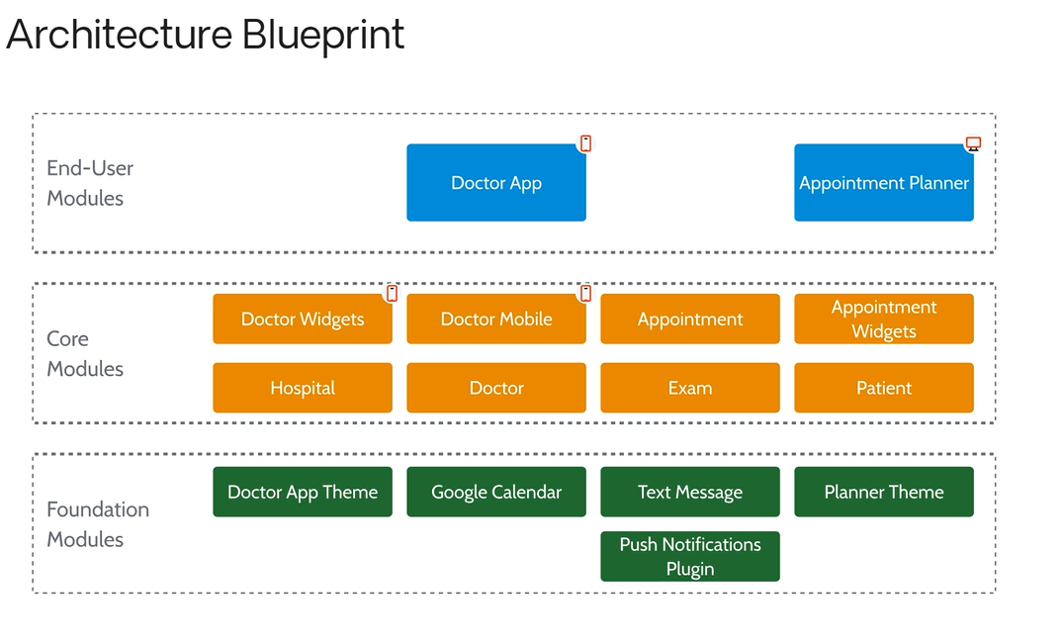

As you identify dependencies between Modules, you can add arrows and obtain the architecture reference map.

Each of the end-user Modules depends on the respective theme.

Each of the end-user Modules also depends on the respective Widgets Modules in the core layer.

The Doctors app also depends on the Push Notifications Plugin to enable registering with the Push Notification third-party service.

The Doctor App also relies on the Doctor Mobile Module for the local storage data, which in turn consumes information from the Doctor and Appointment Modules.

The Appointment Planner web app will need to reference the Appointment Module in order to manage appointments.

As we've mentioned before, the Appointment Module orchestrates the Hospital, Doctor, Exam, and Patient Modules.

It also relies on the Google Calendar, Text Messages, and Push Notifications integrations.

The Doctor core Module depends on the Exam and Patient Modules.

This gets us to the end of our example.

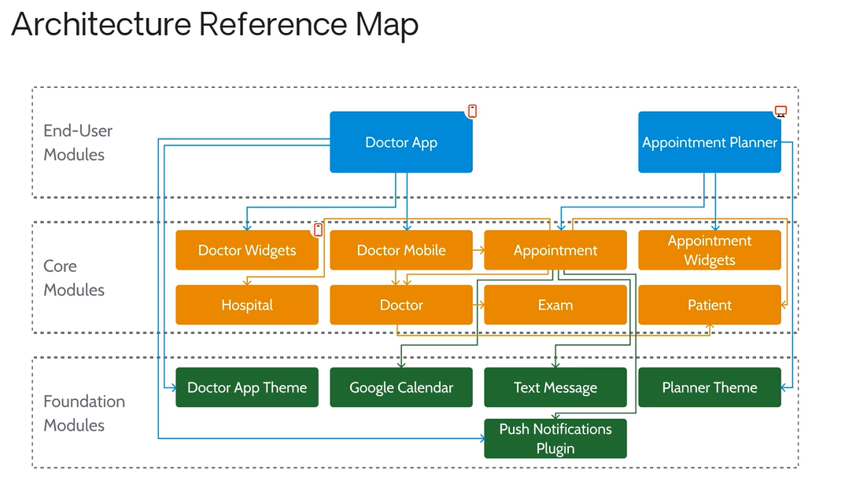

Don't miss our next lessons, where we will talk about the importance of naming conventions for Modules, using the same example.

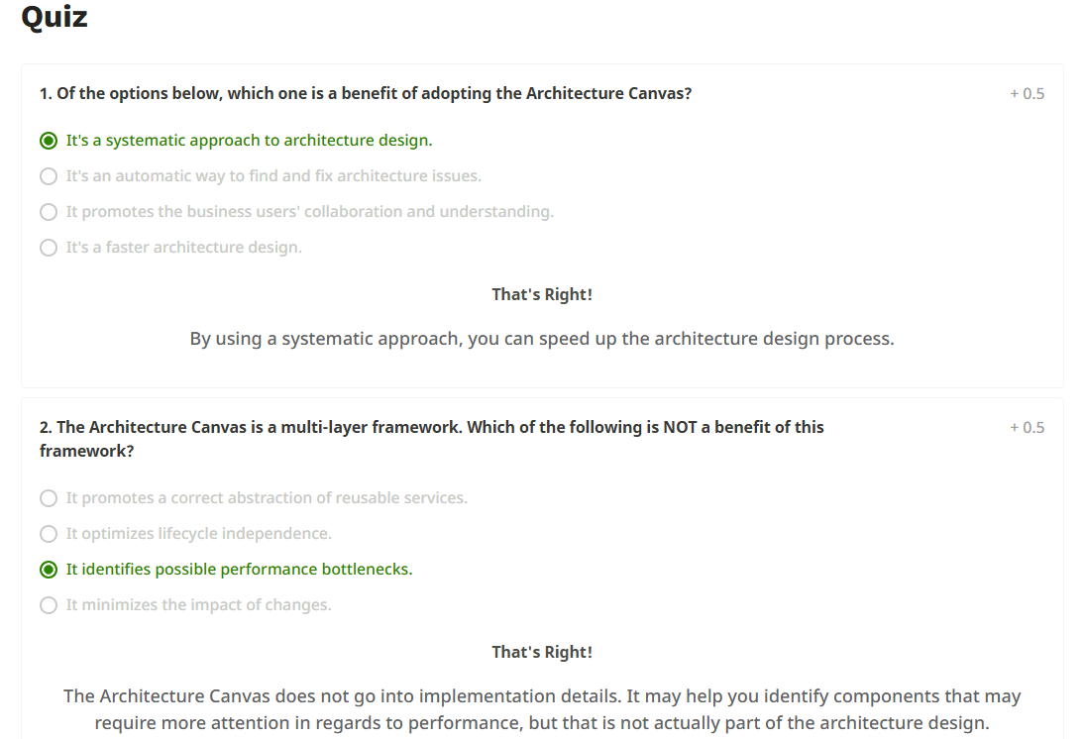  
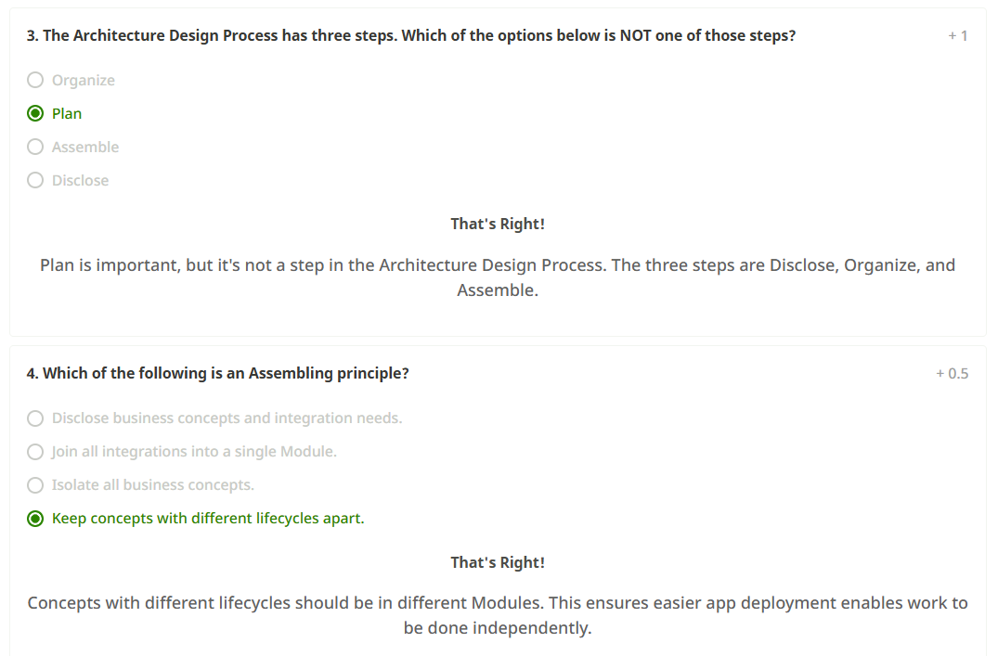

*Architecture Conventions for Modules*Naming Conventions for Modules  
  
In this lesson, you learn why it's important to adopt naming conventions for the Modules you create.

After covering the suggested naming conventions, we'll go back to our running example — the Doctors app — and apply these naming conventions.

Given that different Modules are found in different layers, thinking about their purposes and adopting some naming conventions can be useful.

If we look at this architecture blueprint, it may be hard for someone less familiar with the app to understand the purpose of each Module.

To overcome that difficulty, we suggest following a naming convention for Modules.

Let's see why it's important to adopt a naming convention.

Following a naming convention helps to reveal the nature of your Modules and the elements inside of them.

It also enforces the overall reference architecture while giving you a consistent way of looking at the Modules with which you are working.

As you begin to create larger architecture design patterns, it will normalize those patterns and help communication in general.

As you can see, naming conventions have a lot of benefits, and they are something you should definitely consider.  
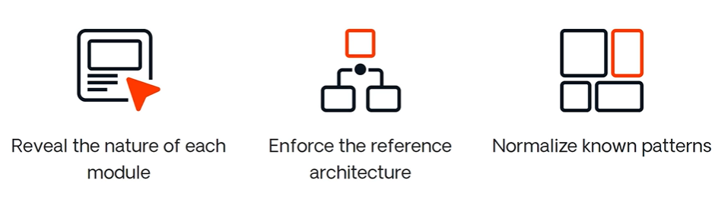

Let's go over each layer in detail.

Starting by the Foundation layer.

The _Lib suffix should be used for generic library Modules.

For integration services that help consume and normalize an external service, we add the _IS suffix.

The _Drv can be used for specific integration services.

Driver Modules can be created to expose the same API, containing specialized implementations.

You can think of these as the drivers for different printers.

You have _Th for Modules containing your app's theme and the overall look and feel elements.

The _Pat is for reusable user interface patterns or blocks.

These should be used for layout and display.

Here, since we are in the Foundation layer, no business logic should exist.

The _Plug is meant for reusable mobile plugins.

If you are creating a mobile-specific Module, prepend an M to your naming convention.

For instance, _MTh or _MPat.

If we move on to the Core layer, Modules become business-aware.

The _CS is used for reusable Core Service Modules.

In these, you will have public entities and actions that are business specific.

A _BL Module is meant to encapsulate business logic.

Here, you will have actions that are going to be exposed.

Similarly, the _CW will hold Core Widgets or blocks.

The Core Widgets Module is where you define blocks to compose different parts of the UI.

You may separate different blocks or patterns into several Modules, depending on their lifecycle.

Sometimes you need to have very technical pieces of business logic that are heavily based on calculations for complex business rules.

For these cases, the Module should have the _Eng suffix.

You might also have the need to synchronize data.

For those cases, use _Sync.

Isolating this kind of logic makes the Core Service completely system agnostic, and makes it easier to decouple or replace parts of the system.

The _API should be for technical wrappers that expose an API to any external consumers.

Once again, if you are creating mobile applications, you can add an M in front of the naming convention for the mobile-specific Modules.

Knowing how to name Modules consistently in the Foundation layer and Core layer can be important, since these two layers have the most reusable services.

For End-User layer Modules, the Module name ends up being part of the URL, so the only recommendation is that they should be short, direct, and meaningful for the end-users.  
 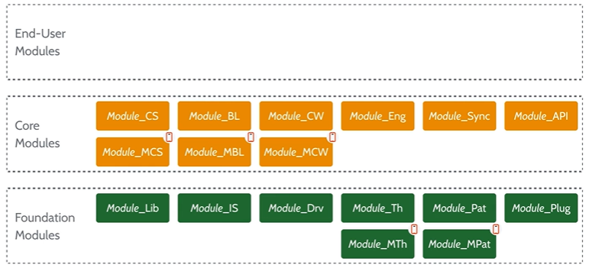

To understand these concepts better, let's apply these naming conventions to our previous Doctors app example.

Starting from the top, in the End-User layer, there is no need to apply any naming convention to these two Modules.

Since their names make sense and are short, it will be okay if they end up in a URL.

The only change is removing the spaces in the Module names.

Going down to the Core layer, these four reusable Modules should handle the core entities of our application, with their public entities, actions, and blocks.

Since these are Core Services, we add the _CS naming convention.

The Appointment Logic Module will include the actions to orchestrate the other Core Services.

This business logic should support most of the Doctor application’s business rules.

So the _BL naming convention is applied.

The Doctor App Mobile Module will handle the synchronization of information between the mobile device and the server, while supporting all the core logic.

So it should be renamed to _MBL.

Regarding both Modules containing business-related widgets, the _MCW and _CW naming conventions are applied.

Going further down to the Foundation layer.

The Push Notifications Plugin Module is a mobile plugin service.

So we add _Plug.

The Google Calendar and Text Messages Modules are integration services with external systems.

So they should be renamed to _IS Modules.

The Doctor App Theme and Planner are theme Modules.

So they should be renamed to _MTh and _Th Modules respectively.  
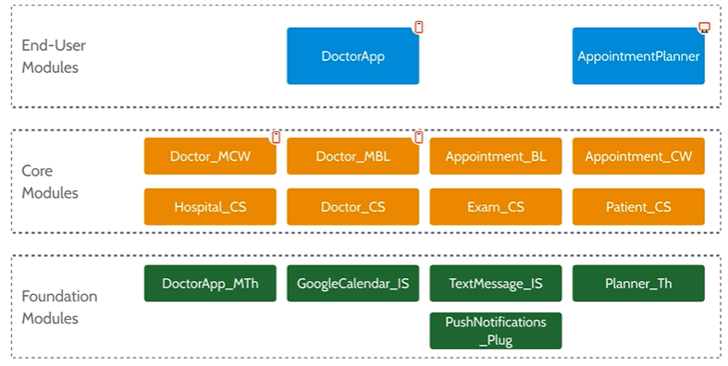

To recap, these are the suggested naming conventions.

You don’t have to use exactly these naming conventions.

They are not mandatory.

You could develop your own naming conventions and apply them in a way that makes sense for you and for your business.

However, it’s useful to define and follow a set of naming conventions.

In the end, it ensures alignment and eases the understanding of the type of elements that will be in each Module.  
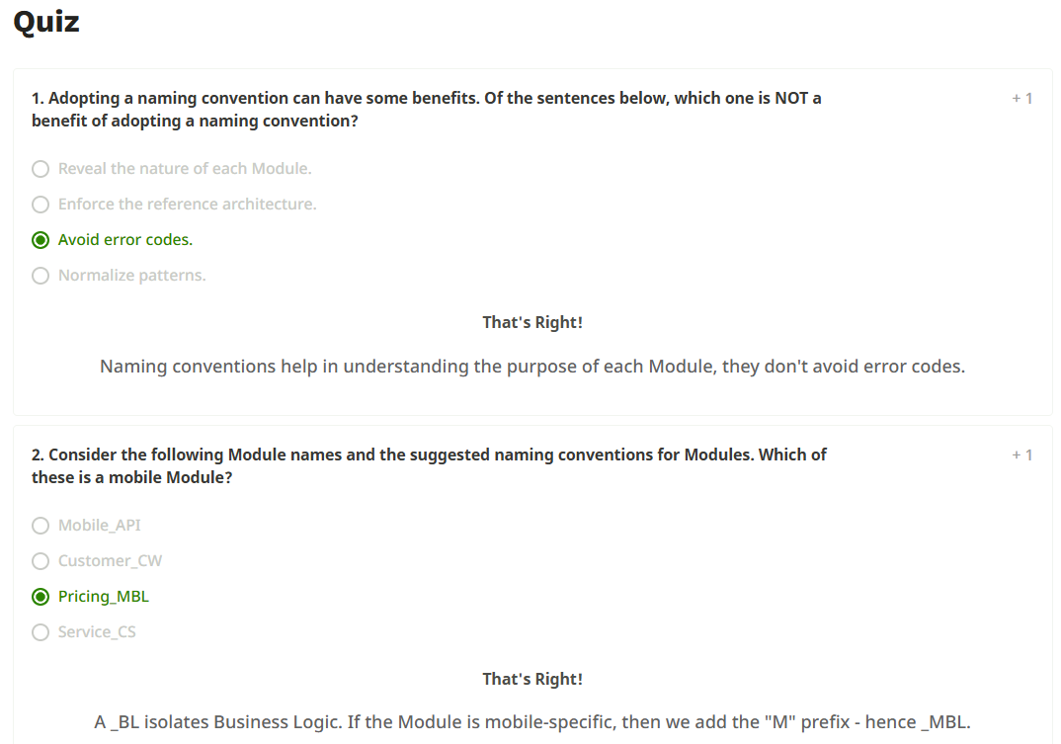  
  
Typical Module Elements  
  
In this lesson, we will look at the typical elements that you'll find inside each layer's Modules.

By now, the Architecture Canvas is no surprise to you. Let's go over each layer and see the typical elements that you'll find there.

Let's start with the Foundation layer, where you will have your integrations and non-functional requirements. The highly-reusable elements are defined in this layer.

From a data perspective, you might need structures for inputs and outputs to handle data exchanges with external systems. However, you wouldn't expect to have any core entities because this is for integration and non-business functionalities.

In regard to logic, this layer provides actions to other Modules in the form of normalized APIs.

If you need to communicate with external systems, then you will probably also need some sort of exception handling. This will ensure that error codes and exceptions that might occur are handled correctly.

If you need customized authentication flows, such as a centralized single sign-on, that is also present at the Foundation layer.

Session logic might also be needed, and the correct place is also in the bottom layer.

Finally, there may be roles. You could store roles common to a particular domain of users. Roles like Manager or Employee tend to be highly reusable, so it makes sense to also put those roles in a Foundation Module.

Also in the Foundation layer, you may have Modules to define highly-reusable UI patterns or blocks, like a calendar.

Themes, layouts, and exception flows are more examples of elements that end up being reused across several other Modules. All of this could be reusable and part of a theme Module that you store in the Foundation layer.  
  
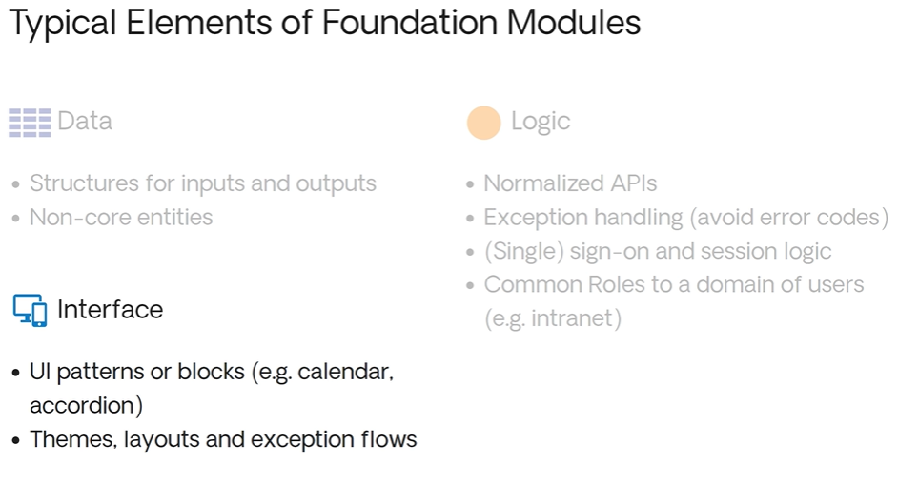

Now, if we move to the Core layer. Core business concepts appear here. The elements here will be consumed by the Modules from the End-User layer.

In terms of data, the core business entities should live here. These entities should be exposed as read-only, and the logic inside the Module controls manipulation of their data.

So, how is data changed by other Modules? Well, you should expose the change operations via Server Actions. By doing this, you have a well-defined API. This makes it easier to set default values as needed, or to perform auditing.

You may also have integration logic that wraps the integration services that exist below, in the Foundation layer.

Finally, in core Modules you would also have roles to define the different types of accesses to the features available in those Modules.

Some of the elements that might be part of those core Modules are reusable UI business blocks. These blocks are business-specific and display information the way you need it for the specific business.

Note that no Screens should be defined in this layer.

With the core entities, you may also have asynchronous data processing in case you want to classify, synchronize, count, or aggregate information. You can use both business processes and timers to perform such tasks.  
  
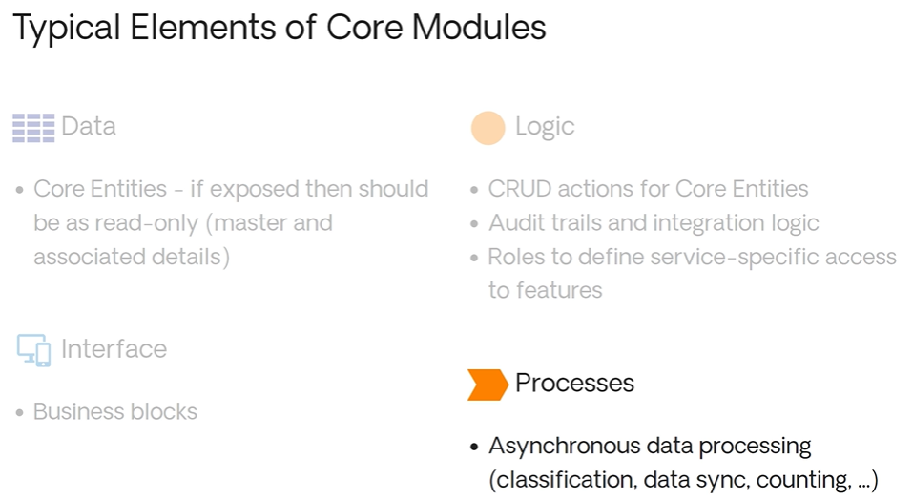

Only one layer remains — the End-User layer.

This is where essentially your Screens and auxiliary elements are defined.

From a data perspective, you'd have potentially different types of entities that would help save the UI status, as well as some auxiliary structures if needed.

Some business logic might exist, but these elements are not reusable and are meant to support specific use cases and UI.

An example would be form validations. You wouldn't want any generic reusable logic in this layer. If that's the case, then you should probably extract it and place it inside a core Module.

Inside the End-User layer, you would expect to find very specific role-based UI to support the use cases or the processes that you're trying to make available.

Finally, you may need the business process itself, defined as a workflow. Any processes that help support the use case would be in an End-User Module as well.  
  
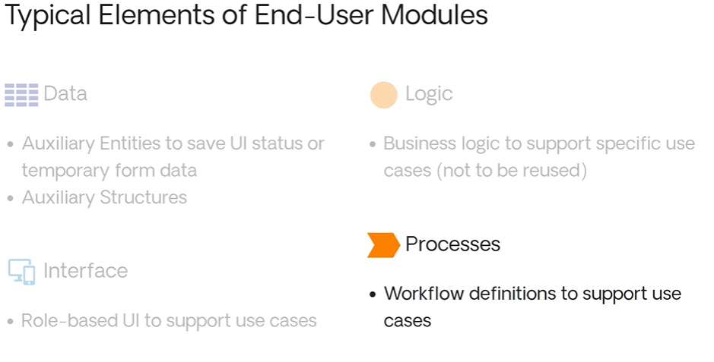

That's it.

Don't miss the next lesson, where we will see the typical Module elements in a specific scenario.  
  
Typical Module Element (Doctor App)  
  
In this lesson, we will look at the typical elements that you'll find inside each layer's Modules for the example we've been following throughout this course — the Doctors App.

This is what the Doctors App Architecture Canvas looks like. We have quite a few Modules. The naming conventions have been already applied. Now, let's check what actual elements are part of each Module.

Let's start with the foundation Modules, more specifically the Doctor App Mobile Theme Module. In here, you should have the common roles and built-in login logic elements. As for the Interface, the layouts, exception flows, and UI Screens to support the mobile login are defined here.

Regarding the Planner theme Module, the expected elements are the same as the ones on the Doctor App Mobile Theme Module. The only difference is the web login UI instead of the mobile login UI for the interface elements.

Now, let's look at the Push Notifications Plugin Module. In terms of data elements, you should have input/output structures and keep the plugin settings of the devices accessing the application. In terms of logic elements, you should have the actions to handle the notifications and validations.

For the Google Calendar integration Module, you have input/output structures and a calendar Entity as data elements, as well as the logic needed to deal with the calendar operations. A normalized API to deal with the Google interface, and exception handlers to support the UI Widget's behavior. Since this is an interface element, you should expect to find a reusable UI Widget here, to be used in different Screens.

Finally, let's take a look at the Text Messages integration Module. It is very similar to the previous one, only with the I/O structures to support the normalized APIs dealing with the external text message service and the TextMessage configuration Entity. As logic elements, you will have the CRUD actions to deal with the text message operations, normalized APIs that encapsulate the logic to deal with external services, and exception handlers.

Now let's move on to the Core layer, and to the Doctor App Mobile Business Logic Module specifically. As data elements, local storage optimized to the defined requirements, temporary and specific Screen data, session info, and the registration process are expected. If any of these data Entities need to be public, they should be set to read-only.

In terms of logic elements, you will have your CRUD server actions and check role actions to assure that only authorized users are able to perform specific operations. The CRUD actions define how data is manipulated. Logic to sync data from the server to the device is also defined here.

In terms of process elements, cleanup tasks are necessary to delete any unnecessary or temporary data.

For the Appointment Business Logic Module, you will have the public read-only appointment data elements. In terms of logic elements, appointment logic actions, CRUD actions, and business rules actions are expected. Since this is the Module where appointments will be created, timers or business processes might be needed to create or validate doctors' agendas, and to send notifications. Cleanup tasks to support information maintenance are also expected as process elements.

Regarding the core services Modules, mostly data elements and their respective logic elements are expected — meaning the read-only business Entities with their respective CRUD actions and business logic.

As for the Core Widgets Modules, these will hold the definition of logic elements to support the UI Blocks. Which means that inside these Modules you will also have the actual Widgets or Blocks.

Now let's move up once again to the End-User layer and to the Doctor App end-user Module. Here, the expected interface elements are mobile Screens, with their auxiliary structures and temporary data elements, as well as logic elements like screen validation actions to support them.

For the Appointment Planner End-User Module, the same elements as in the previous Doctor App end-user Module are expected. The only difference is that they have web Screens as interface elements instead of mobile Screens.

And that's it. Don’t miss the next lesson, where we will introduce the application composition concepts.

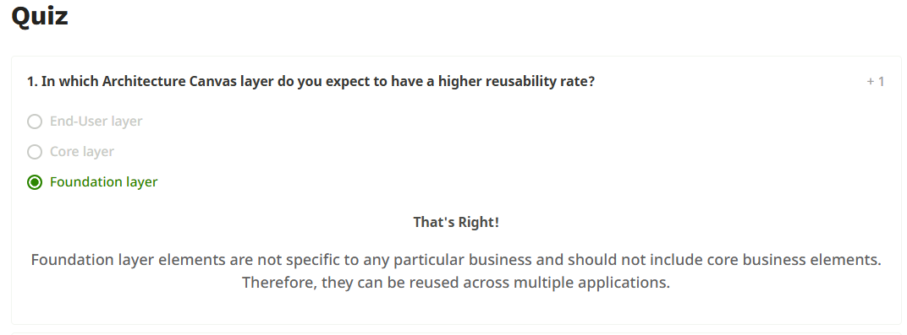  
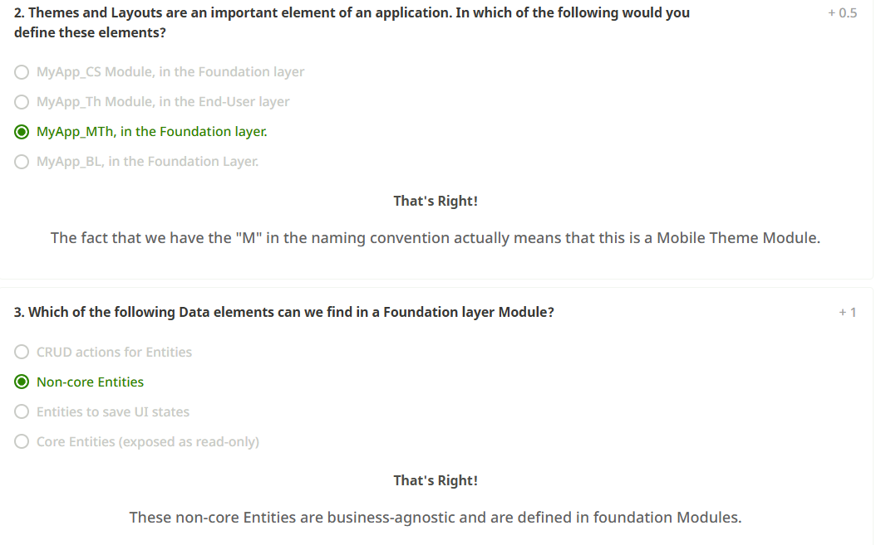  
  
The application composition process  
  
In this session, we'll get back to what OutSystems applications are. After that, we'll see how Modules are composed into the architecture canvas for applications. All of this will get more clear as we return to the Doctors App example and apply the application composition process.

If you remember from Service Studio, an application is composed of a set of Modules. These Modules can contain any kind of elements: screens, logic, data, and even processes. But why is this important?

In OutSystems, when you deploy your code into the Quality or Production environments, you actually deploy applications. So, you have to select one or more apps and then deploy them. When one app has dependencies on others, in order to actually move forward with the deployment you may need to add more apps to your deployment plan.

So, in this context, an application is the smallest deployment unit.

Similar to Modules, applications also have a canvas. The layers are the same; however, within each layer we will have apps instead of Modules. An app layer is defined by the topmost Module layer inside of it.

Let’s see this in more detail.  
If the app only contains Foundation Modules, then it is a Foundation app.  
If the app is composed of Core Modules, then it’s a Core app.  
If the app is composed of both Core and Foundation Modules, the app is still categorized as a Core app. The topmost Module is a Core Module; therefore, it is a Core app.  
Apps composed only of End-User Modules are considered End-User apps.  
If the app contains Core or Foundation Modules as well as End-User Modules, it is still an End-User app. The topmost Module is an End-User Module. The same is true if the app contains all kinds of Modules — it is also an End-User app.  
  
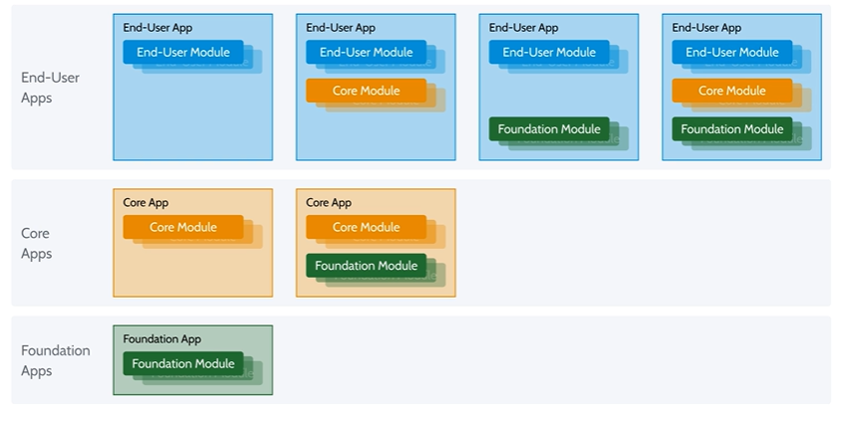

Let's recover our running example — the Doctors App. Now, by looking at the dependencies between Modules, let's try to group them and initiate the application composition process.

First, to the right we have an empty Architecture Canvas for applications. We'll move the Modules from the left canvas, group them, and place them into the canvas to the right.

Remember that the Doctor mobile core Widgets, mobile business logic, and the Doctor App theme are exclusive to the Doctor application. So we can package them together into the Doctor App application. As the topmost Module of this application is an End-User Module, this is an End-User application.

Similarly, the Planner theme, core Widgets, and the corresponding Web Module can be packaged into the same application. So you will have the Appointment Planner application. Once again, this is also an End-User application, since it contains one End-User Module.

In the Core layer, an option is to compose all the core services and business logic Modules into a single application. So the Hospital Core Services application could be created with these Modules. Since all Modules are Core Modules, this is a Core application.

Push Notifications Plugin Module should be kept in its own application. Therefore, the Push Notification Plugin application is created.

Both integration services can be packaged together, so Appointment Integration Services is defined. Here, since the topmost Module of this application is a Foundation Module, this is a Foundation application.

So here's one possible outcome that constitutes a valid architecture in terms of applications.

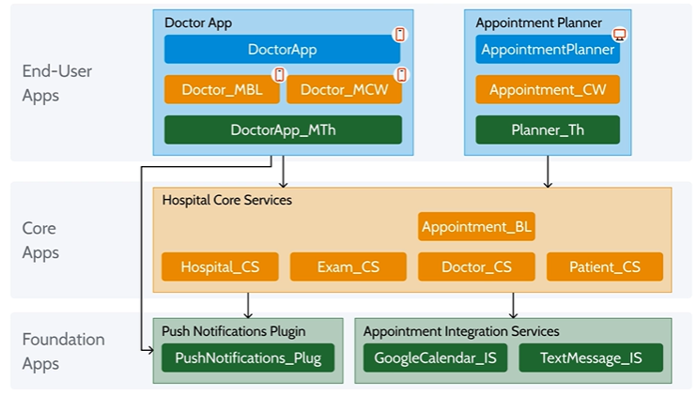

Remember that the goal is to make your deployments easier. Make sure your applications reflect the different life cycles of the Modules and adjust as needed.  
  
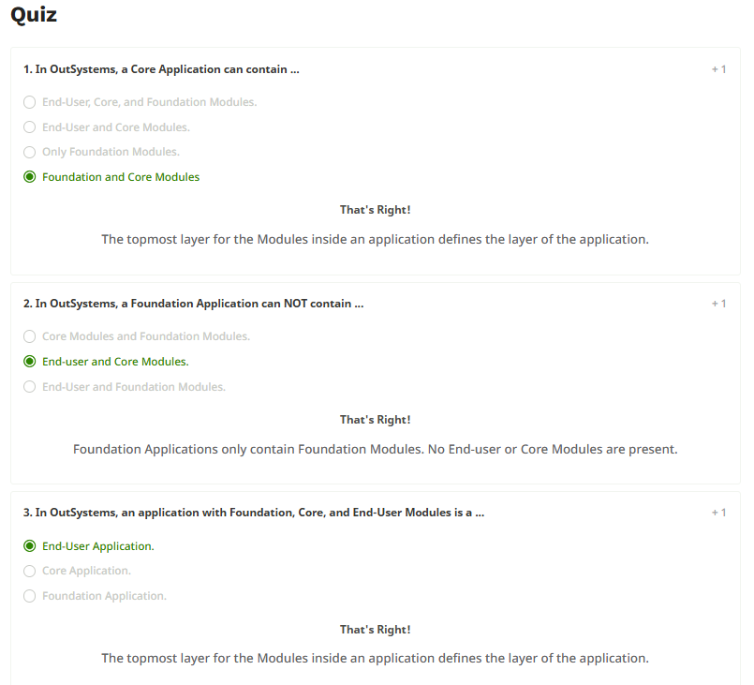

Validating an Architecture  
  
Validating Modules’ Architecture  
  
In this lesson, you will learn why validating your architecture design is so important. We will explain the Architecture Canvas validation rules for modules and also present some extra recommendations that will help you achieve a solid architecture design.

Designing your architecture properly will allow you to build applications fast, build them right, and build them for the future.

From an architecture standpoint, our goal is to promote the correct abstraction of reusable services and components, optimize lifecycle independence, and minimize the impact of changes.

Therefore, validating the architecture of a solution is an important step to prevent and avoid mistakes that will lead to issues like poor service abstraction, unmanageable dependencies, and slow-moving, inflexible legacy systems.  
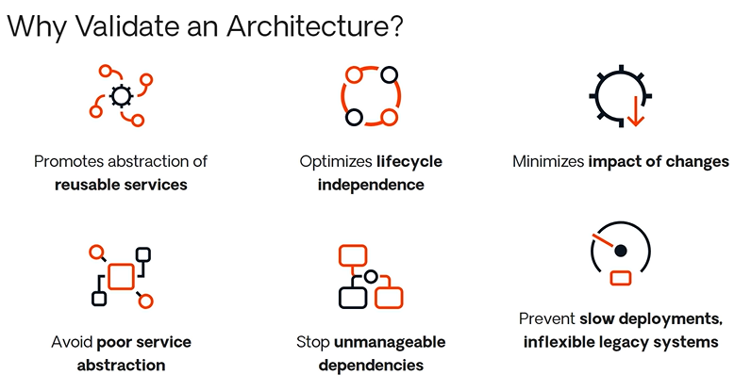

The way we do that with OutSystems is by using the Architecture Canvas.

After designing your architecture and placing the modules in the correct layers of the canvas, you need to validate what you created to make sure your architecture is sound.

In order to perform this validation, you must follow a set of basic rules.

**Rule 1: No Upward References Across Layers**

A module in a lower layer should not reference a module in a higher layer.  
An upward reference can create a cluster where modules have circular dependencies. This means any module that references a module in the cluster becomes dependent on the entire cluster.

For example, if Core Module 1 can reach Core Module 2 indirectly and vice versa, then any End-User Module consuming from Core Module 2 might also become dependent on the entire cluster — causing large deployment footprints and unnecessary updates.  
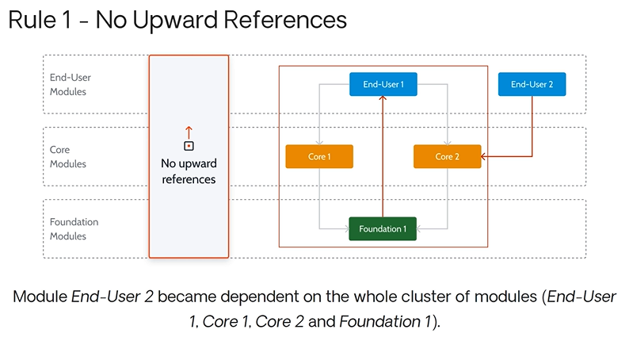

**Rule 2: No Side References Between End-User Modules**

Modules must be correctly isolated to have different lifecycles.  
If End-User Module 1 references another End-User Module, it becomes part of a cluster that shouldn't affect it.  
Instead, promote shared logic or data to a Core module.

**Exception:** Screen references between End-User Modules are allowed. This is explained further in OutSystems documentation under strong and weak references.  
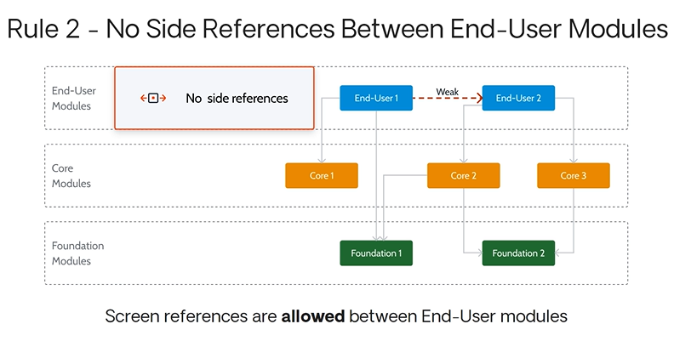

**Rule 3: Avoid Cycles in Core and Foundation Modules**

Even after following Rules 1 and 2, you should still avoid circular references within Core or Foundation layers.  
Cycles indicate poor abstraction and introduce unexpected dependencies and impacts.  
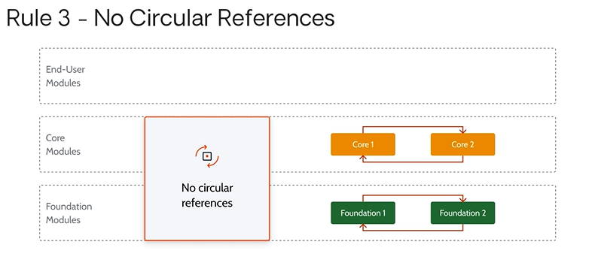

These are the three validation rules for modules:

1. No upward references across layers.
2. No side references between End-User Modules.
3. Avoid cycles in Core and Foundation layers.

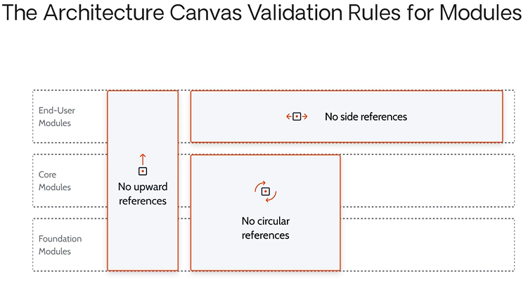

They are easy to remember and help you prevent design issues in your architecture.

**Additional Recommendations**

**1. Core Modules should not contain front-end Screens.**  
Sometimes test screens are added during development. These should be removed and placed in an End-User testing module. Keeping them in Core can risk security breaches if they end up in production.

**2. Public Entities should be set to "read-only".**  
This prevents external modules from directly modifying data.  
Instead, expose safe public actions from Core modules that enforce business rules.

**3. No Business Logic in Foundation Layer.**  
Foundation modules must be business-agnostic to support cross-domain reuse. Avoid business-specific rules here.

**4. No Core Entities in Foundation Layer.**  
Only non-functional elements like auditing or logging should exist in Foundation. It’s fine to have Entities, as long as they support non-business functions.  
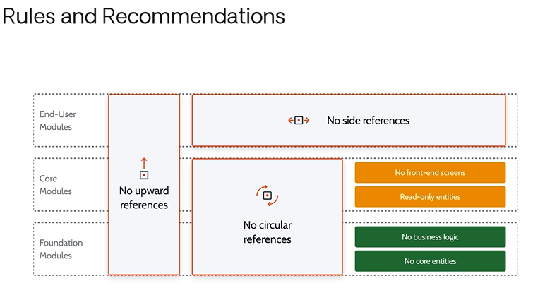

Now you know the three Architecture Canvas validation rules for modules, along with four key recommendations to ensure solid architecture design.

In the next lessons, we’ll explore the validation rules for applications and the tools that can help validate your designs.

Validating Apps’ Architecture

In this lesson, you will learn why validating your application's composition is important, and the four validation rules that can help with that.

As we have seen, our goal is to promote the correct abstraction of reusable services and components, optimize lifecycle independence, and minimize the impact of changes. This makes validating architecture an important step to prevent and avoid mistakes that can negatively affect these goals.

A typical OutSystems factory usually consists of multiple applications. Although validating the modules within each application is important, it is not enough to ensure the application’s composition is correct.

Therefore, it is essential to validate your architecture at the application level to ensure it is sound and easy to deploy and maintain. For that reason, we need to understand the rules to validate application composition in the Architecture Canvas.

At this point, you should already be familiar with the rules and recommendations for validating module architecture. If these concepts are unclear, please refer to the previous video on module validation.

### ****Four Rules for Application Composition****

#### **Rule 1: Follow the Module Validation Rules**

The first rule for correct application composition is to follow all previously discussed rules for modules:

* No upward references
* No side references between End-User Modules
* No circular references

If these are not correctly applied within an application, there’s no point in expecting the application composition to be correct.

#### **Rule 2: Apply Layering Logic to Applications**

Just like modules, applications should be layered properly, based on how they reference each other.

Remember: the topmost module in an application defines which layer the application belongs to in the Architecture Canvas.

**Example**:  
You build an End-User App composed of an End-User module, two Core modules, and a Foundation module. It follows all module validation rules, so packaging everything together is fine.

But if a second End-User App references a Core module from the first App, you’ve now created a **side reference between End-User applications**.  
This results in:

* Tightly coupled deployments
* Shared lifecycles
* Increased risk of regressions

**Solution**:  
Isolate the common functionality into a **shared Core application** that both End-User applications can reference. This improves modularity and flexibility.  
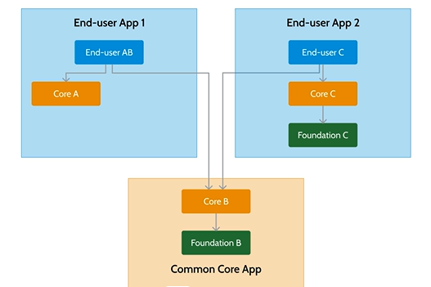

#### **Rule 3: Don’t Mix Ownership**

Each application should have **clear and single ownership**.

Owners are responsible for the functionality within an application. Mixing ownership creates confusion and makes deployment management difficult, as it’s unclear who is accountable for what.

**If shared ownership is unavoidable**, consider splitting the application to ensure accountability is clear.  
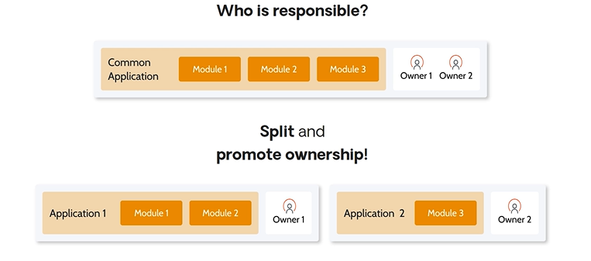

#### **Rule 4: Don’t Mix Sponsors**

Each application should have **one business sponsor**. Sponsors have different priorities and delivery cadences.

**Example**:  
If a simulation portal includes simulations for multiple insurance lines of business, and they are all part of a single app, the **slowest line of business** will dictate the release cycle.

**Solution**:  
Split into multiple applications — one for each line of business — so that each sponsor controls their release timeline independently.  
Shared components like the Simulation Portal itself can be in a separate, common application, governed by a different sponsor (e.g., the marketing team).  
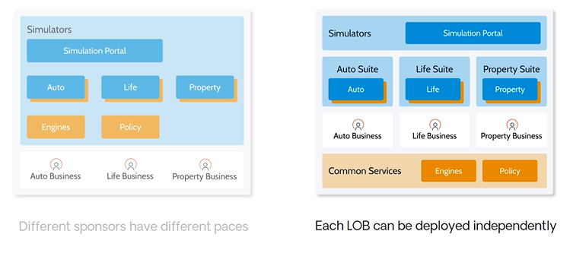

### ****Recap of the Four Rules for Application Composition****

1. **Layer your modules correctly** and follow all module validation rules.
2. **Layer your applications correctly** and avoid side references between apps.
3. **Don’t mix owners** — ensure clear ownership of each application.
4. **Don’t mix sponsors** — isolate business areas so they can release independently.

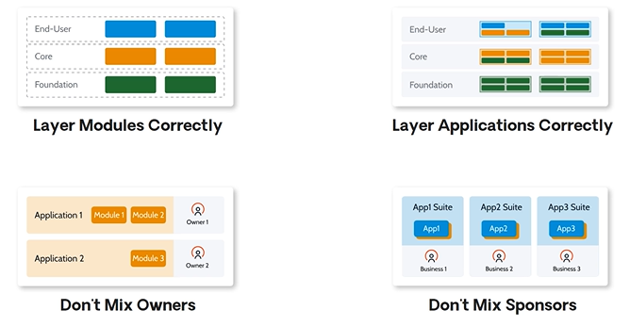

Now that you know these rules and concepts, don't miss the next lesson, where we will present the **tools you can use to validate your architecture**.

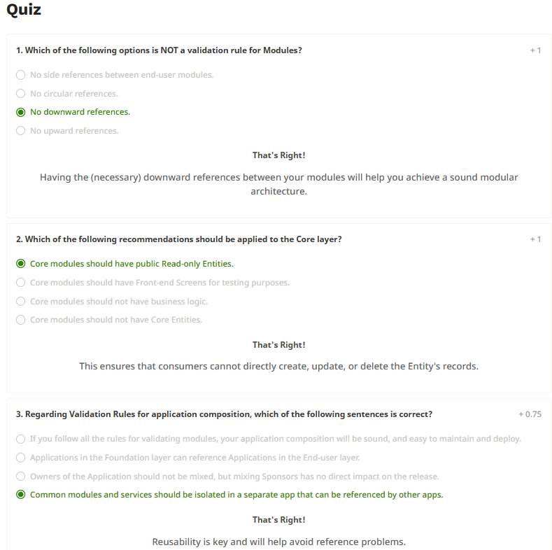

### Architecture Validation Tools Tools to Validate Your Architecture

In this lesson, you'll learn about important tools that can help you validate your architecture. These tools automatically analyze your modules and applications, allowing you to review the findings and identify improvements to ensure your applications are robust and high-performing.

The two primary tools are:

* **Discovery**
* **AI Mentor Studio**

**Why Not Manual Validation?**

While manual inspection is possible, it becomes difficult—especially in complex projects. Manual validation is time-consuming and prone to errors or missed violations that could negatively affect your architecture. Using the right tools makes the validation process faster, safer, and more efficient.

**Tool 1: Discovery**

**Discovery** is a visual analysis tool available for free on the OutSystems Forge. It helps you:

* Analyze, measure, and improve your architecture.
* Validate module and application architecture.
* Visualize module dependencies and how they follow Architecture Canvas layers based on naming conventions.
* Reassign modules to different layers manually.
* Detect dependencies among modules and identify elements each module consumes and exposes.
* Highlight violations of architecture validation rules and suggest improvements.

It also provides a **view of application dependencies**, making it easier to detect validation issues at the app level.

**Tool 2: AI Mentor Studio**

**AI Mentor Studio** is used to monitor and manage technical debt. It allows users to:

* Visualize the architecture of all applications in the infrastructure.
* Identify performance, security, architecture, and maintainability issues.
* Prioritize based on technical debt severity and frequency.

**Key features include:**

* Lists code patterns and their impact.
* Offers actionable tips for resolving problems.
* Uses a color-coded system (Red = Low Agility, Green = High Agility).
* Displays agility ratings at both app and module levels.

**Who Uses These Tools?**

These tools benefit various roles:

* **Architects** can assess the technical debt across the infrastructure and track architectural evolution.
* **Team Leads** can review their team’s application health.
* **Developers** can identify and fix technical debt, ensuring best practices are followed.

**What’s Next?**

### In the next lesson, you’ll see demos of Discovery and AI Mentor Studio, which will help you understand exactly how to use these tools for architecture validation. AI Mentor Studio – Walkthrough

Let’s take a look at **AI Mentor Studio in action**!

If you’re using it for the first time, you’ll need to **log in and complete the setup** by following the on-screen instructions. In this example, the setup is already complete.

Once logged in, the **AI Mentor Studio dashboard** displays a list of all applications in your environment. Each application is **color-coded** to show its **technical debt status**, which ranges across **five levels**, from **red** (high technical debt) to **green** (low technical debt).

A higher level of technical debt means the app has **more issues** or **more severe problems**, which may relate to:

* **Performance**
* **Security**
* **Architecture**
* **Maintainability**

For each issue (or *pattern*), you can **drill down to the exact location** of the finding. For example, a problem might be found in a SQL query named GetRatings, which resides inside the FieldEventsManager module.

Note: **AI Mentor Studio does not fix the issues automatically**—developers are responsible for making the changes.

**Key Features**

* You can open the findings **directly in Service Studio**.
* You can view details at both the **application level** and the **module level**.
* Each module also uses the **same color-coded system** to reflect its own technical debt.

By clicking a specific module, you can access its **module report** and see the individual findings, just like at the app level.

**Final Note**

Thanks for watching this walkthrough of **AI Mentor Studio**.  
Keep using it to **identify issues and reduce your technical debt** effectively!

**Discovery Tool – Walkthrough**

Welcome to this demo where we explore the **Discovery architecture tool** in action.

We already have several apps in our environment, so let’s begin by **installing Discovery** from **OutSystems Forge**:

* Search for **Discovery**
* Click **Install**
* Wait for the installation to complete

**Launching Discovery**

After installation, open Discovery.

On the **initial screen**, you’ll see:

* An **overview of all apps and modules**
* The **total number of apps and modules**
* Any **architecture findings** detected in both apps and modules

If you don’t see data right away, give it a moment and refresh — Discovery needs to load information initially.

**Module Canvas View**

In the **Module Canvas**, Discovery:

* Automatically classifies **modules** into layers based on **naming conventions**
* Displays **consumer and producer module counts**
* Allows you to expand arrows to view **referenced elements**

If a finding exists, it’s clearly indicated. Clicking it will show the **exact elements** causing the issue — helping you understand how your architecture behaves.

**Customizing Classification**

Module classification is customizable:

* Adjust **naming conventions**
* Click **Auto Classify** to apply changes
* You can also **manually change** a module’s assigned layer

Once adjusted, Discovery **revalidates the architecture** based on **Architecture Canvas rules**.

**Applications View**

Just like with modules, the **applications view**:

* Lists apps in your environment
* Shows **architecture findings** and **dependencies** in a visual format

**Snapshots & Reanalysis**

Discovery works using **snapshots** of your environment:

* To **refresh the analysis**, capture a new snapshot
* This lets you track changes and continuously improve architecture

**Conclusion**

Use **Discovery** to:

* Analyze app/module structure visually
* Detect and fix architecture issues
* Maintain a clean architecture by keeping findings close to **zero**

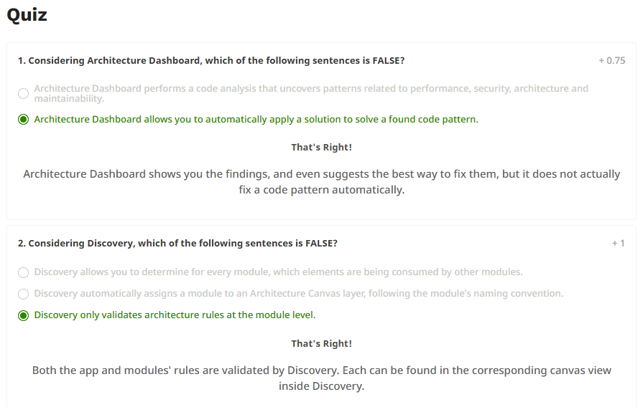

Architecture Patterns in OutSystems  
  
Hi there, and welcome to the **Architecture Patterns in OutSystems** course overview!

Understanding architectural patterns is a natural next step once you're familiar with the **basics of architecture** and **application design**. This course is all about recognizing **reusable patterns** and **best practices** to improve the quality of your applications.

**Course Structure**

This course is divided into **two main sections**:

1. **Library Module Patterns**
2. **Core Module Patterns**

These patterns are organized according to their respective **layers** in the **Architecture Canvas**.

**1. Library Module Patterns**

This section covers the **base layer** of the architecture:

* **Extension Pattern**
* **Connector Pattern**

The **Connector Pattern** emphasizes the importance of ensuring the **correct granularity** of the APIs being used. These are the building blocks that often handle communication with **external systems**.

**2. Core Module Patterns**

This section focuses on patterns found in the **core layer**, including:

* **Core Entity Pattern** – the most common, based on the purpose of this layer
* **External Core Service Pattern** – used when core entities are sourced from external systems. This includes:
  + A **base version**
  + Several **variations**
* **Transparency Service Pattern** – a commonly used core module pattern for data or logic transparency

Some core module patterns are **aggregates** of other patterns (e.g., connectors), making them **more complex and involved**.

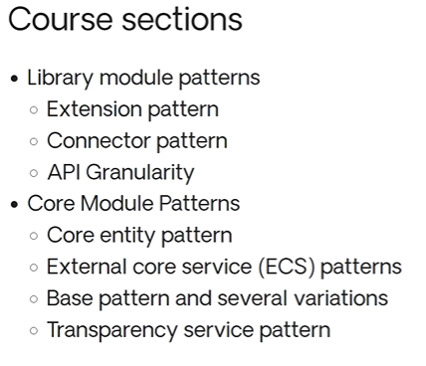

**Why This Order?**

* We start with **Library Modules** because they serve as the **foundation**, often managing external connectivity.
* Then we move on to **Core Modules**, which may build upon or include library-based connectors.

**Course Goal**

By the end of this course, you'll:

* Understand the most **effective architecture patterns**
* Learn how to design **reusable and scalable services**
* Be better equipped to apply **best practices** in real-world OutSystems projects

That’s it for the overview — let’s get started!

Library Module Patterns.

Hi there, and welcome to this session on Library Module Patterns.

In this case, when we use the term "library," we're referring to the library layer of the architecture canvas, so we'll be covering the most common patterns that are used in the library layer.

We'll start by doing a quick review of the library module elements and the types of elements that are key to different types of patterns.

Then, we'll jump into looking at two key library module patterns: the **extension pattern** and the **connector pattern**.

Then we'll talk a little bit about how, when some of these patterns are being used, we have to be careful about the **granularity of APIs** that are created.

So, let's go ahead and get started.

There are a number of different typical elements that we might find inside of library modules.

From a **logic perspective**, we would find normalized APIs. These would map to the external systems and provide information in a way that's consumable.

We may also find **exception handling**, in which we'd want to avoid different types of error codes.

For example, if we have an integration to a web service of an external system, where that system returns some boolean with an error code, we wouldn't want to propagate the error code to our consumers. Otherwise, they have to be aware of the details of the external system, and we want to insulate them from having to know those types of details.

So we can hide those pieces of information inside of the library module that performs the call.

We can do the test as to whether it's successful or not, and then throw an exception if necessary.

**Exception handling** should be the normal way that these types of things are handled, especially when we use them inside of patterns.

We could also have logic inside of a library module that deals with **single sign-on** and different types of **session logic**.

That will help us interact with the external system but hide how that interaction occurs from the consumers that are planning on using those APIs.

From a **data perspective**, we would expect to find **structures for inputs and outputs** for calls that will be made to those normalized APIs.

We also may find **non-core entities** that aren't business-related. These types of entities might be something like **points on a map** or other types of information when we're integrating with systems that don't directly relate to the business but are still important.

From the **UI level**, we may find **UI widgets**. We would not find full screens, but we might get **standardized components** like a calendar or an accordion.

We also want to be able to extract and reuse **themes, layouts, and exception flows**, so those could be included inside of library modules as well.

Also, we may have **roles** from a specific domain, like a company's intranet. Common examples might be **employee** or **manager**, and we would include these in a library module so they can be reused across multiple applications.

This can help prevent the creation of similar roles in multiple applications that would require administration and changes to all of those roles any time a common role changes.

So these are some of the **typical elements** that we're going to find in library modules.  
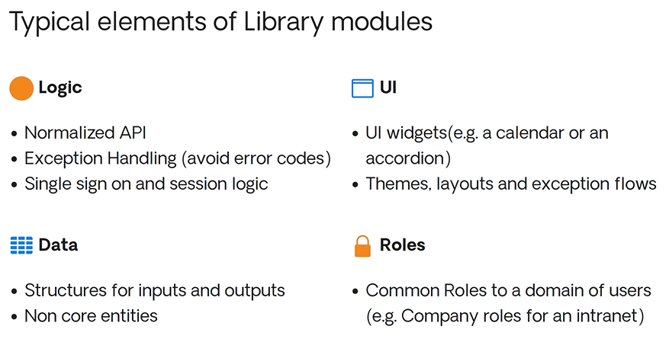

**Common Library Module Patterns**

A very common library pattern is the **extension pattern**.

An extension generated by Integration Studio can be a **wrapper to an external code library**, such as a .NET code library to generate a PDF.

Here we can see that our wrapper contains the **logic**, the **actions**, and the **data** that will expose the code inside the external library.

This way, things inside of the OutSystems environment can use all of the functionality from the external library.

Another type of **extension pattern** is a wrapper that will **wrap entities from an external database**.

We'll use Integration Studio to introspect the external database and import the data structures, so they can be used as entities inside of OutSystems.

Entities created this way can behave like regular OutSystems entities. They will have **entity actions**, and can be used inside of **aggregates** as well.  
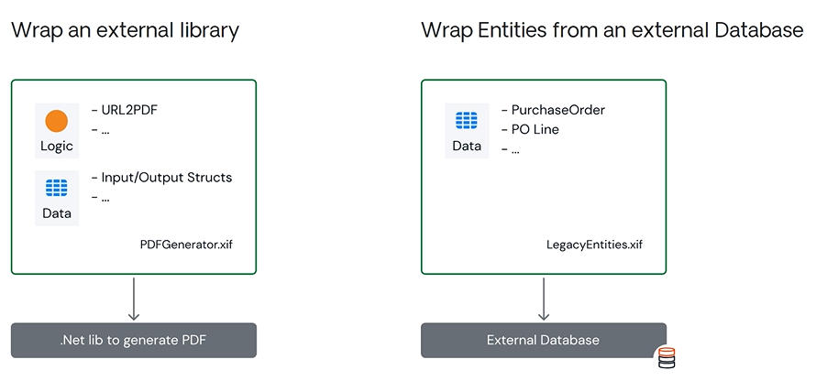

**The Connector Pattern**

Another important pattern is the **connector pattern**.

The connector pattern consists of **two modules**:

* An **extension module** to encapsulate an external API
* A **wrapper module** to expose a **normalized API** to consumers

For example, the extension module might be a **Salesforce connector**, and the wrapper module (Integration Service or "IS") would expose the API for consumers.

The extension module will encapsulate the external API, allowing Salesforce queries with input and output structures suited for that API.

The **wrapper module** abstracts the external system details and simplifies the interface for developers.

For example, instead of calling a “Salesforce Query,” the wrapper module exposes an action like **Account Search**.

This is more intuitive and aligned with **business use cases**.

The wrapper also manages **session logic** and can normalize **business concepts**, using meaningful data structures like **Account** or **Opportunity**, instead of generic "return objects."  
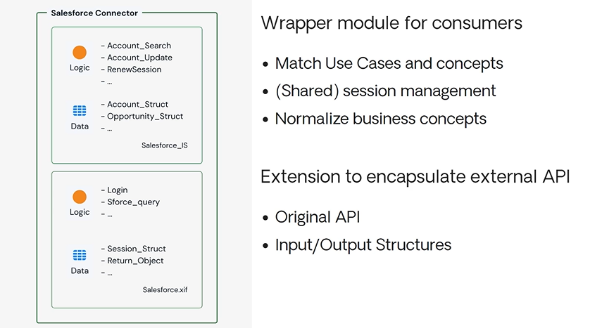

**API Granularity Considerations**

An important consideration in the **connector pattern** is maintaining the **right level of API granularity**.

When working with **large external systems** like SAP that have **hundreds of BAPIs**, exposing each one might lead to hundreds of APIs and structures in your integration service.

Instead of having one huge integration service, it’s better to **split by functional area**.

For example:

* **SAP Financials**
* **SAP HR**
* **SAP Materials Management**

These would still connect to the same SAP system but avoid bottlenecks and make the solution easier to **maintain and scale**.

This also means users of one API (like Finance) won’t be affected by changes in another (like HR).  
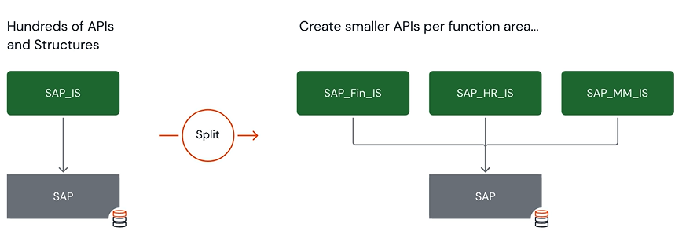

**Summary**

In this lesson, we looked at the elements typically found in **library modules**, and how they support:

* Exception handling
* Session management
* Data transformation
* UI reuse
* Role centralization

We explored two key patterns:

* The **Extension Pattern** (for wrapping external libraries or databases)
* The **Connector Pattern** (for encapsulating and exposing external APIs with proper granularity)

That’s it for the **Library Module Patterns**.

Thanks for listening!  
  
Core module Patterns  
  
Hi there, and welcome to this session on Core Module Patterns.

In this session, we'll start with a quick review of the different elements that we might find inside of core business modules, which will be in the core layer of the Architecture Canvas.

Then we'll begin looking at the core business module patterns, which are patterns that start in the core layer but may involve other layers as well.

So we'll look at the core entity pattern.

We'll look at the external core entity service patterns, and there are several of these types.

We'll look at the base external core service pattern, and then there are variations, so we'll look at the local replica and the synchronization variations, and we'll look at the direct integration variation and a pub/sub variation.

Then, there are also variations, not just in the way we approach it, but sort of how we deal with the different calls that are made, so we'll look at local caching and lazy loading variations as well.

Then, to end, we'll look at another important pattern called the transparency service pattern.

So, a lot of things to review. Let's go ahead and get started!

As we begin introducing the patterns in the core business module layer, we'll begin to see that there are a number of typical elements that we find inside of core business modules.

From a UI perspective, we would not expect to see Screens or UI Flows in a core module, but we would expect to see Blocks that might be available to consumers.

For example, if we wanted to expose a Block that contained a summary of a product, it could include an image, a description and the price, and would provide a standardized way of reusing that whole summary.

From a logic perspective, we would expect to be able to find all the necessary change operations for our core entities, as well as other requirements like audit trails or integration logic.

The operations that are made available to consumers could hide any of the side-effects or extra logic that would be included.

From a data perspective we would expect to have core entities representing our core business concepts.

These entities should be exposed in a read-only fashion, to ensure that the core module is properly abstracting all of the change operations that need to be made available.

This prevents consumers from performing transformations on the data in some sort of uncontrolled way.

We also may have a need for asynchronous data processing.

This may include data synchronization, or any type of digest information that might need classifications or counts of that data.

The idea here is to have the core module abstract the way the data is handled, so the relevant data is available immediately to the consumer, and they don't have to know as many of the details.

Asynchronous programming inside of OutSystems is either done with Processes or Timers.

So, there are a couple choices as to how we would approach that.

Finally a core module can also expose different types of roles.

These roles may be different than other types of roles that could be shared from maybe a library service.

Those might be company-wide types of roles.

In this particular case, for the core modules, they may be specific to some sort of feature that's implemented in the module.

If we have a module that's focused on products, we might have a role like product administrator, who would be able to edit the details of that product, and then that could be used inside of our logic, and inside of our blocks to go ahead and restrict access to certain types of functionality.

Now that we've seen the types of elements that we expect to find inside of the core modules, let's look at some of the common patterns in more detail.

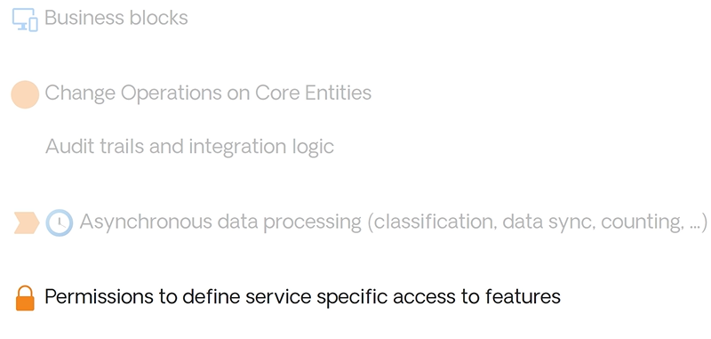

The most common pattern for a core Module is: the Core Entity pattern.

It would expose Entities around the core concepts, like Product or Product Family.

It would also expose all the logic to perform updates on those Entities, and any Blocks that might provide reusable UI components to show the data about those Entities.

A core Entity should be reusable by one or more applications.

If we had a recall process, a supplier audit, and a store audit process, all of them would need to know information about products.

So, if we had a Product Services core Entity, it could be exposed as a read-only Entity, and we could create a set of actions in logic that would become the API to centralize exactly how those Entity records would be created and updated.

This pattern is fairly simple and straightforward, because our core service is the system of records, and is storing the data in Entities inside of OutSystems.

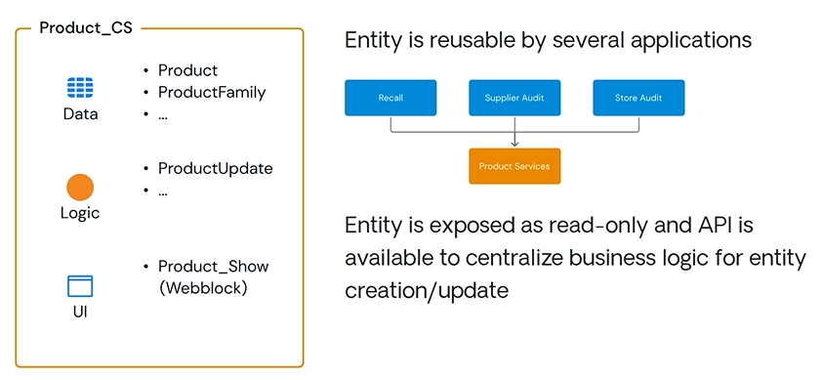

Let's look at another key variation of this Core Entity pattern.

If we think of an example where the system of records isn't OutSystems itself, but might be an external ERP system, we would implement an integration service in the library layer to abstract the external system, and get the data into our core service module.

In this case there's no Entity storing the data in the core service.

The core service is just providing an API that makes the remote call to the external system, whenever the data is needed.

This is what we call an external core entity, or the external core service pattern.

Often we refer to this pattern as the ECS pattern, because in this case our core Entity, although it has the capabilities and the look of a regular core Entity, the information is coming from an external system.

Something that is important is that this integration service in the library layer, that API, must support all the use cases that the external core service is going to be able to support.

This is such a key service that there are actually many variations of this service.

In this particular case, we're seeing an example where the external system is still the system of records and we're not keeping any data at all.

This approach can actually impact the external system if we're making a large number of calls.

It can also have performance implications due to the latency of the call through the integration service to the external system, and the fact that every call needs to go through both sets of systems, and then return to actually get the information back.

The data retrieval may not actually be optimized as well.

There are some drawbacks to this, and we need to think about how we would be able to get information from the external system in a little bit more detail.

The external core service has two main variations that can help us with the location of the data.

One is having a local replica, and another is doing synchronization.

If we go ahead and list the external core service pattern here as a reference, then we can go ahead and look at different variations of this pattern.

The first variation can be an improvement over the base pattern, because we're going to use a local replica of the external core system's data.

In this pattern, we'll provide local Entities to this core service to cache the information from the external service.

This will end up looking exactly like the Core Entity pattern, because we'll now have some public Entities that would allow consumers to retrieve the data.

This pattern should also have some sort of asynchronous processes to retrieve data from the external systems, and store it in the Entity that is serving as the local cache.

Now, some advantages of this approach include the ability of this Entity to retrieve data, and also use things like scaffolding and other accelerators inside of OutSystems.

Also, this integration API can be much simpler, because we don't need all use cases to go to the enterprise resource planning system, the external system.

We only have to have an API that allows us to get all of the updates that are needed since last synchronization has occurred.

Any type of composition or filtering of data that might be needed by the consumer, can actually be performed using the local cache.

Of course this approach also ends up having a smaller impact on the external system, since we don't need to make as many requests to get the data.

The second variation is very similar to the first, with the main difference being that we're going to isolate the synchronization logic into its own module.

Having a synchronization module is a pattern that we promote, not only because the consumers of the core service don't need to consume the synchronization logic, but also we wish to have code independence, which allows us to update either of these sets of codes independently.

This would allow us to update the synchronization logic without impacting the consumers of the core service, and the synchronization logic may be orchestrating the synchronization of several core services, in which synchronization order is important.

Sometimes, when we're synchronizing data from an external service, we may not be able to synchronize all the data, because it's too much data.

If we only need a subset of the data, then the synchronization module can use the integration service to get the information it needs from the external service, and then it can use the core service to go ahead and update the information in the local cache.

That synchronization sequence, sort of implies that we no longer need the reference from the core service to the integration service, but we will have this direct reference, because whenever a consumer wishes to perform updates we should first perform the update through the integration service on the external system, and then once we know the update was successful, we can update the local cache as well.

The external system is still the system of records, and we try hard to avoid two-way synchronization whenever possible, because that can be a lot more complicated.

This means that the updates are being done synchronously, while the larger synchronizations are really being done asynchronously.

It also means that we may need to deal with the occasion where someone updates the external system, and it didn't originally come from our core service, or any of the other pieces of this architecture.

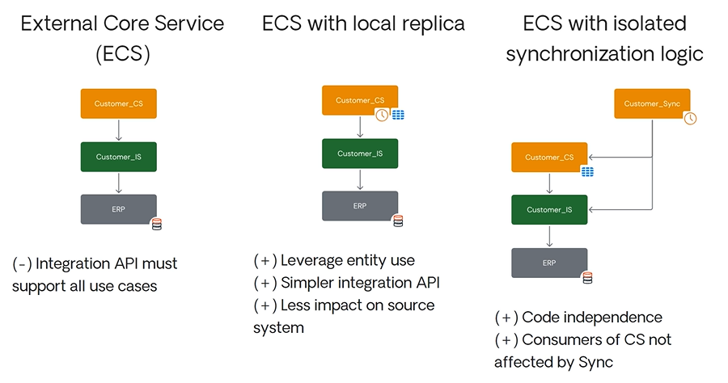

Another variation of the external core service pattern is one of direct integration.

Instead of using a synchronization process to retrieve data at certain times, we may want to be able to immediately react to any change on the external system.

In this case, we need to provide some sort of API to the external system, so it can notify us when a change occurs.

Then we can use the normal path to go ahead and get the changes from the external system.

This is basically a kind of subscription mechanism.

This type of pattern leads us to our final ECS variation, which introduces an Enterprise Service Bus, or an ESB.

If there's an ESB, which is providing publish and subscription services, and we can adapt the previous pattern to have the core service actually publish to the bus, and the external system to be able to subscribe for that information from the bus.

We can also have the external service publish other changes to the bus, which would then be subscribed to by the core services API.

When we're getting data from an external system, sometimes there's too much information.

Either because we don't have all the attributes of a particular Entity, or because we don't need all the records of a particular type of data.

There are variations of these patterns that can help us regulate the amount of data, and not just the timing at which we get it.  
  
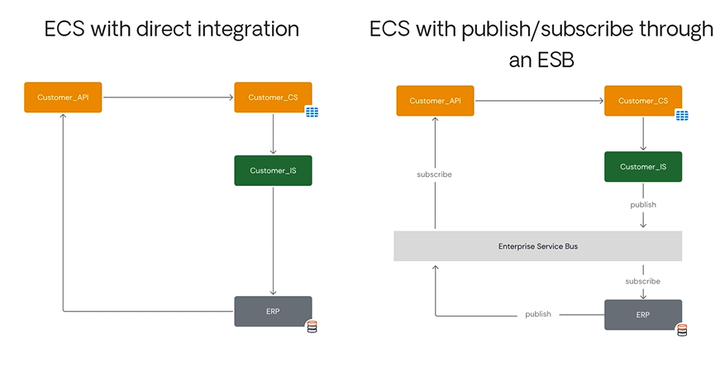

Let's take a look at some of those.

The first is the summary cache only.

We would cache only the summary data that is frequently listed, joined, or searched.

The full details for a single entry will be fetched directly, whenever they're needed, but the summary data will actually be kept in the cache.

We want to use this when the whole database or whole set of entities is too large or too costly to synchronize, and the details are only required for single entries.

We'd actually see the list select one, and then be able to get that, which should be a fairly small call that could happen very quickly.

With the list actually inside the cache, the list can constantly be refreshed quickly, and we'll be able to see that in the user interface.

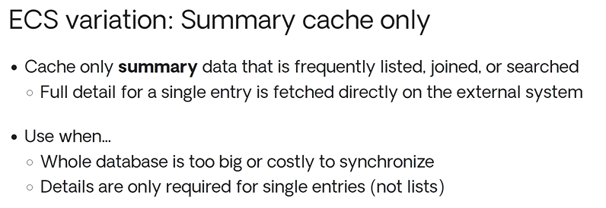

There's also the lazy loading variation, where we try to fetch the data from the local cache entity.

If it's not there, then we go and get the single entry from the external system.

We then cache that record which is sometimes referred to as read-through caching.

This can be very useful when the whole database is too big or too costly to synchronize, and our integrations are only going to get small sections of the database.

We do want to avoid this though when we need access to a list and we need that information up front.  
  
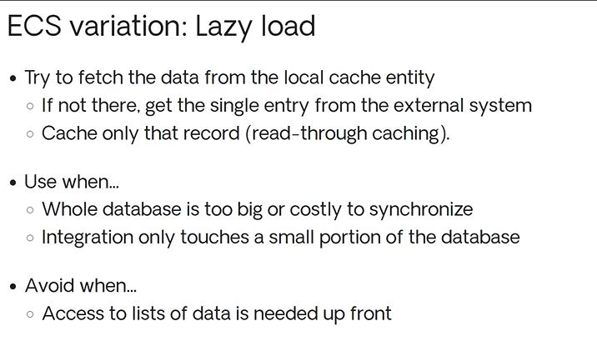

The final pattern that we'd like to discuss is the transparency service pattern.

The transparency service pattern typically provides information that may be coming from various external systems.

For example, we may have all of our enterprise customers in the first ERP, all of our medium-sized customers in our second ERP, and many of our small customers in our SAS system.

In this case, the integration service will decide which driver to use depending on the type of customer that is encountered.

Each driver exposes the exact same API, but they integrate with their specific external system.

The core service, can then use the integration service, and synchronize or cache the data as necessary.

We can also simplify this transparency service, when we don't need to perform updates from the core service.

In that case, the integration service isn't even necessary, because the decision for where to retrieve the data could be handled by the synchronization, or the core service itself.

If we take a look at that and draw it out, we could see a one-way transparency service that is simplified, where the integration service is gone.

We decide that the synchronization service will talk to the drivers, and decide how to retrieve the information, and then consumers can get the information they need from the local cache.

In this case there won't be any updates coming through the system to these ERPs, because we're just reading information.

It's important to see these types of illustrations, because for any of the patterns that we've talked about or any of the variations, we can make minor modifications to these patterns to deal with the instances of given scenarios.

As long as we keep the correct level of abstraction, we are trying to reduce the impact of the different life cycles on the individual modules and code that are there.

If we can manage that complexity, then we can always modify the patterns to fit the situation, as best we can.  
  
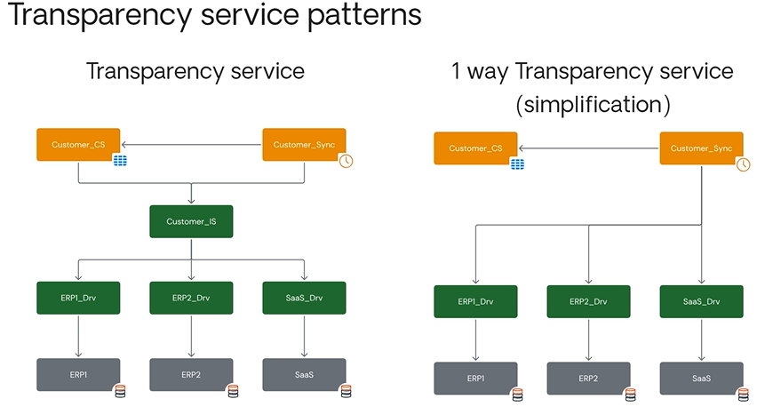

As a quick review, we went over the elements in the core business modules, and then we looked at some of the typical patterns.

We looked at the core entity pattern, and then what happens when that core entity pattern becomes an external core entity, and then we get the external core service patterns.

We looked at the base pattern when we have local replicas, and how to do synchronization, as well as how to do direct integration and pub/sub.

Then we looked at large information scenarios where we could do a local cache, or we could do lazy loading, and we ended up by talking about the transparency service pattern.

We covered a lot of complicated information in this session.

Hopefully you enjoyed the core business patterns.

Thank you for listening!  
  
Style Guide Architectures  
  
Welcome to the lesson on Base Style Guide Architectures. In this lesson, we'll give you an overview of what a Style Guide and a Live Style Guide are.

After that, we'll explore the OutSystems UI built-in Style Guide. A Style Guide works as a tool and a guide for UX/UI designers and developers when they are designing and implementing apps.

It defines a brand's visual communication. On the other hand, a Live Style Guide is an instantiation of the Style Guide. It provides a visual guide to create a consistent and beautiful user experience on your apps.   


A Live Style Guide is an app that showcases the actual elements and follows the Style Guide rules and best practices.  
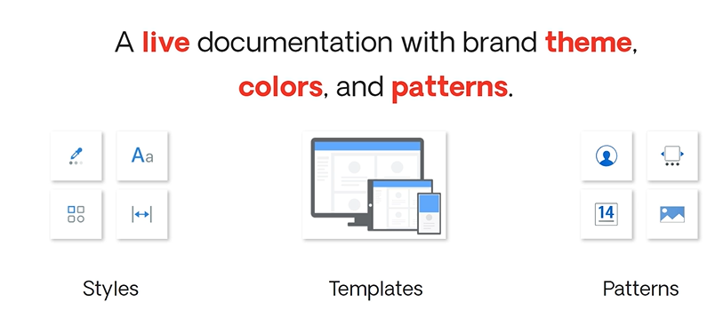

OutSystems UI is a framework that provides a series of elements to help create Reactive Web and Mobile apps. It provides three elements to help with that. The Theme - For the look and feel of your applications, which includes Screen layouts, the global stylesheet, and grid definitions.

The Templates - Defines the structure of the application Modules. A template contains Screen definitions and provides a basic set of functionalities, including authentication. Patterns (or blocks) - Provide common and reusable UI functionality. Chat message, date picker, and carousel are a few examples.

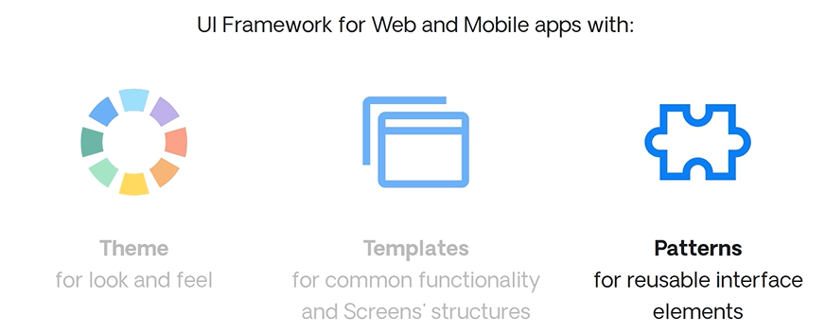

In terms of architecture, we have several elements. The main reusable theme contains the main CSS styles and classes.

The template Module contains the base definition (such as references to the theme) and common layouts and menus that can be shared between several applications. This Module is automatically cloned when you create the first Module inside a Service Studio app. The patterns include UI and Widgets that are standard, reusable components. The Live Style Guide includes Screen examples, so developers can understand the Style Guide's look and patterns.

Other Modules within your app will reference the App Theme and reuse it in order to keep a consistent look and feel.  
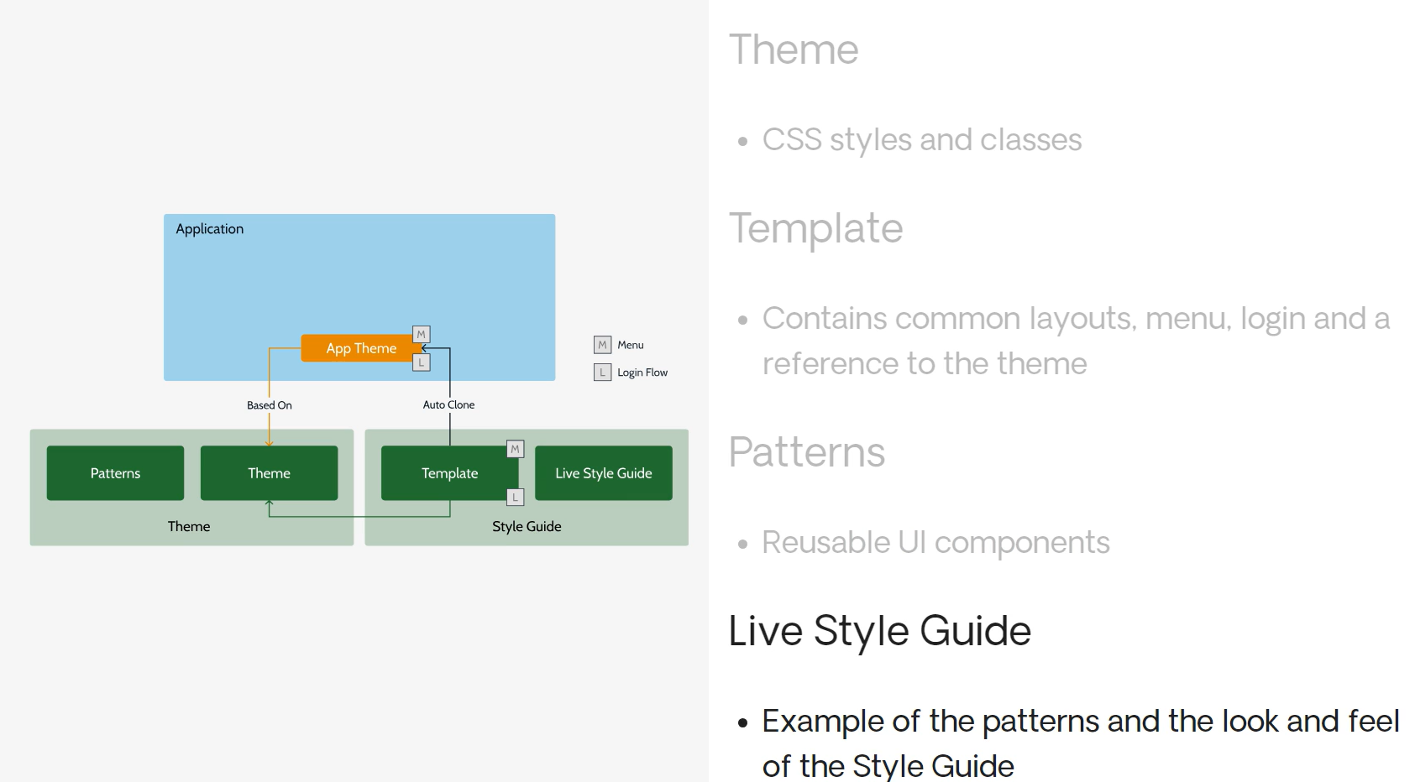

So, why is it important to define a Style Guide architecture? If you don't do it up front, some issues can occur later on. In terms of performance, it is important to only load the necessary resources, such as images, CSS, and JavaScript. All apps can easily adopt the same Style Guide, reducing long-term maintenance and refactoring due to the fact that all look and feel assets are centralized.

It will also help development by reducing the dispersion of the look-and-feel code across several Modules and preventing custom inline styles across many Modules. These are some advantages of defining a Style Guide up front.   
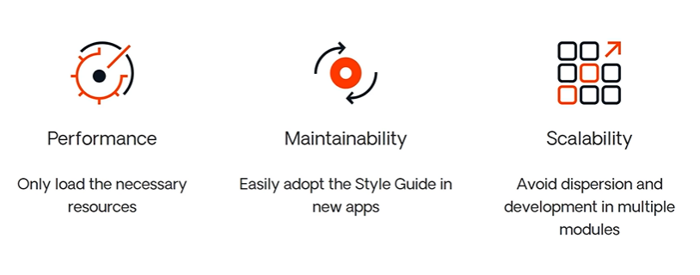

In the next scenario, we'll see how the OutSystems UI Style Guide is structured. When the first UI Module is created inside an app, it will be a clone of the chosen template, which in turn references the theme.

The template contains the menu and login UI and logic. Those elements are also cloned into the first Module of application.

This means that the application will have its own menu block and also the exception handling flow, where authentication is done.

The application theme is the place to do minor look-and-feel customizations. It is also the place to customize the login, menu, or the common header.

When more Modules are created inside the app, they will reference the first Module—the App Theme.  
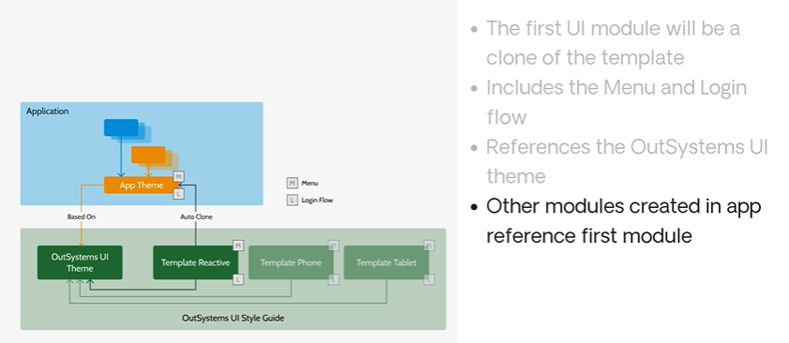  
 In the next lesson, we'll see how this works in Service Studio.

Custom Style guide Architecture

In this lesson, we'll start by introducing you to the four Style Guide common scenarios. By the end, you'll understand the three possible and common ways of sharing and reusing a Style Guide. In the previous lesson, we learned that a style guide helps define the structure, look, and feel that will be shared across your applications.

Here, we have the four common scenarios of a Style Guide architecture. Let's check each of them in detail.   
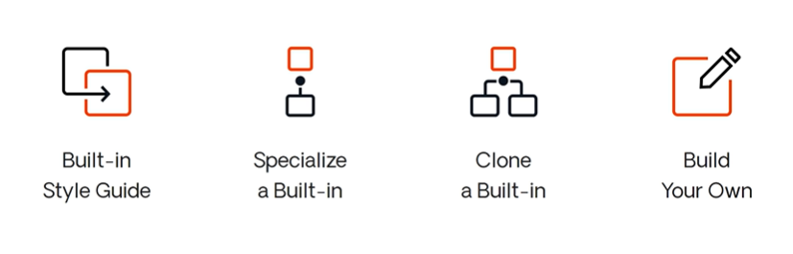  
Let's start by recapping the built-in Style Guide, which is the base scenario. Here, your apps will use the built-in Style Guide from OutSystems UI. The first module of your app will actually be a clone of the chosen template and will include the Menu, Login, and a reference to the OutSystems UI theme, among others. Other Modules inside the app will reference the first Module you've created in that app.

Minor customizations to the Base Theme should be done inside the App Theme.  
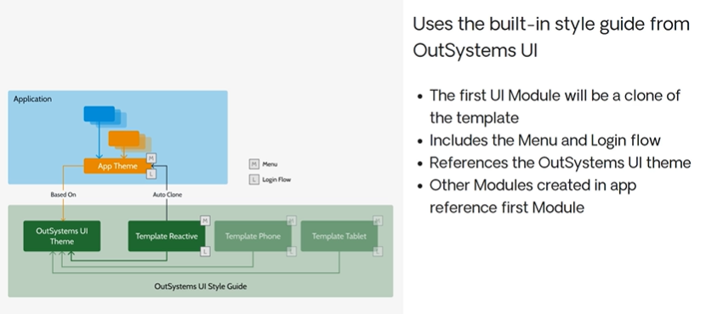

The second scenario can be seen as an evolution of the previous one. Specializing a Style Guide makes sense when the changes you want to introduce to an existing Style Guide will be shared across multiple applications.

The first step is to create the Custom Theme and Custom Patterns, which are actually an extension of another theme. Then, the Custom Template is cloned from an existing template and will reference the Custom Theme created before. New applications are created from the cloned Custom Template, which in turn is based on the Custom Theme.   
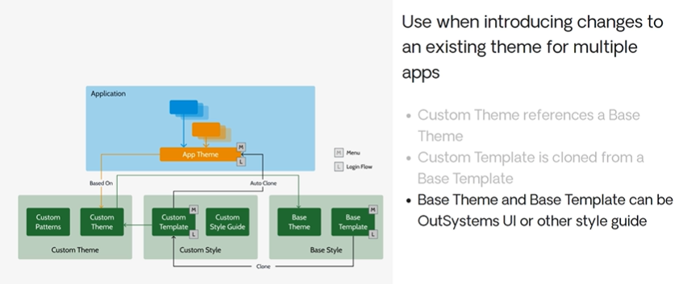  
Doing this has the benefit of inheriting the built-in theme, but it will have an impact on performance, due to the extra imports of CSS and other resources.   
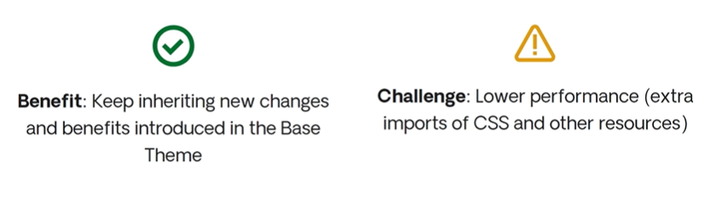

The clone scenario is applicable when the amount of changes to an existing Style Guide are extensive.

We recommend you clone the built-in Style Guide and start from there. In this case, the Custom Theme is a clone of a Base Theme. Note that here, as opposed to the specialized scenario, the Custom Theme does not extend the Base Theme. The Custom Template is also cloned, but from the Base Template, and it will reference the created Custom Theme. Then, new applications will use the Custom Template and will be based on the Custom Theme. Here, just like in the previous scenario, the Base Theme and Base Template can be cloned from OutSystems UI themes and templates, or any other themes and templates you might already have.   
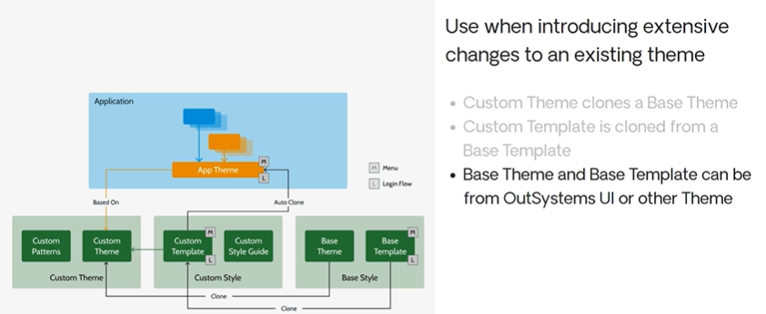

This option is the most performant one because it has one less indirection—namely the reference between the Custom Theme and the Base Theme. However, it won't benefit from changes introduced in the Base theme, since it is a completely different Module.   
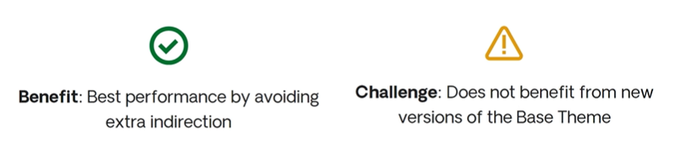

This last scenario is kind of the fallback and should only be used when the Custom Style Guide you want to build cannot benefit from any existing theme.

The suggested strategy consists of cloning the template and theme, as in the previous scenario. However, here we recommend you clone the Base Theme from OutSystems UI. This theme contains the bare minimum required structure and styles. With this base structure, it is up to the front-end developer to expand and design the theme from there.   
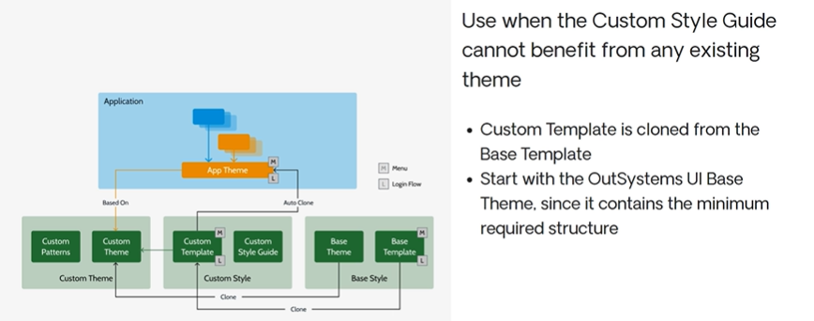

So far, we've seen different approaches to create a Custom Style Guide.

Let's now see in more detail how elements such as the menu and login can be shared across different apps that use the same Style Guide. The first use case is when we have different applications and each one requires its own menu and login flow. In this case, the menu and login are defined in the template.

This means that for every new app, the menu and login are cloned and specific to the new app. Note that different apps still share the same Custom Theme. Another common use case is when the login flow needs to be shared, as usually happens with Intranet apps. The menu remains in the template and will be specific for each app.

However, the Login flow is actually defined in the Custom Theme and will be shared between apps. Finally, the portal scenario is where all apps have a shared menu and login flow.

That is, they are both defined inside the Custom Theme, and all apps will reference them.   
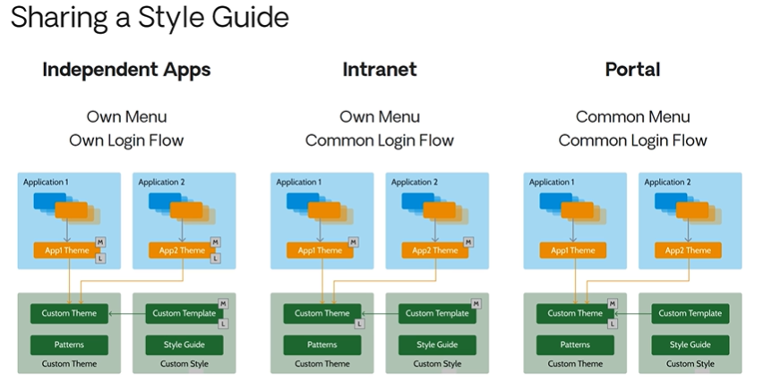

Where the menu and login-related elements are defined depends on your Style Guide's purpose and how you want to reuse each one.

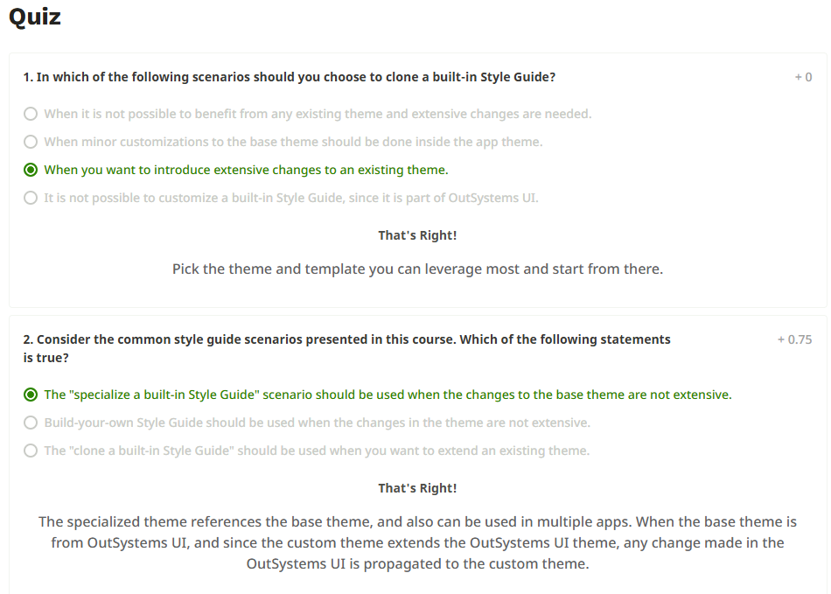  
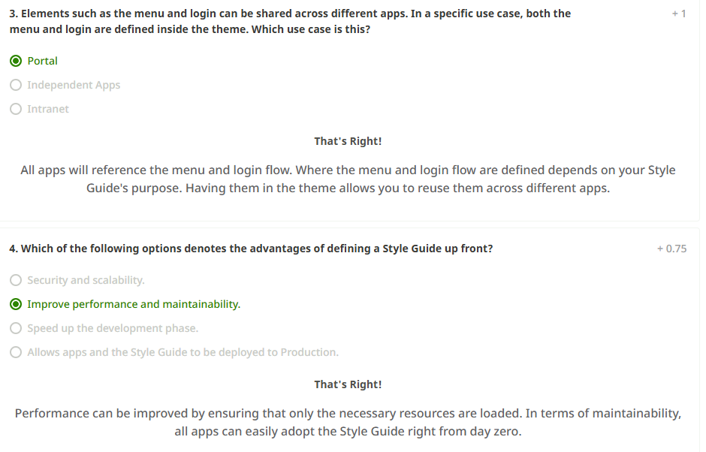

Refactoring an Application

### ****1. Introduction to Refactoring****

Hi there, and welcome to this session on Refactoring an Application. While building applications or solutions, we can use the Four-Layer Canvas to follow the architecture design process and implement some of the common patterns to try to create sound architectures. But what happens when we have to modify our current applications and architecture to deal with new requirements or new applications that will help the business grow? Or what happens when we're presented with applications that aren't following the principles and the best practices? In such cases, we may need to refactor those applications to create a sound architecture.

### ****2. Refactoring Goals and Overview****

In this session, we're going to discuss the prioritization criteria for fixing violations that we find so that we can refactor our applications in the best possible order. We'll also look at ways to promote loose coupling, which will give us a couple of different choices to deal with certain sticky situations but will allow us to refactor things and give us a number of choices.

### ****3. Refactoring Techniques****

We often can solve refactoring problems by moving elements between modules, so we'll discuss how that's possible. Sometimes we have difficult situations where we need to extract elements from a module and not impact consumers that had already been consuming those elements. There are a number of different things that we need to focus on. We're going to leave this last one for a different session because there are a lot of details, but we'll do a quick overview here to keep all of the refactoring information in one place.

### ****4. Prioritization Criteria****

Here are some prioritization criteria that can be helpful to determine the order in which we should approach refactoring. One important thing to remember here is that every time we do a refactor, we should only be doing the refactoring and not including any new development. It's important to take refactoring changes to production before adding any new elements.

### ****5. Fixing Violations in Priority****

We should fix violations in the order in which the fixes will have the most impact. At the top of the list, we should fix and remove any upper and side violations in the end-user layer. The second criterion is to solve direct cycles between modules in the core layer. Next, we should solve any violations to the core layer. Finally, we need to solve direct cycles between libraries. The prioritization criteria give us a nice way of choosing which of the different types of violations we should address first.

### ****6. Handling Multiple Violations****

If we find multiple violations in one category, pick the module with the most consumers first, as that will solve the most amount of conflicts. If we're using the Discovery tool, we can sort modules by impact to prioritize better.

### ****7. Refactoring Actions****

To fix a violation, we might need to move elements between modules, extract elements, or revise implemented patterns.   
  
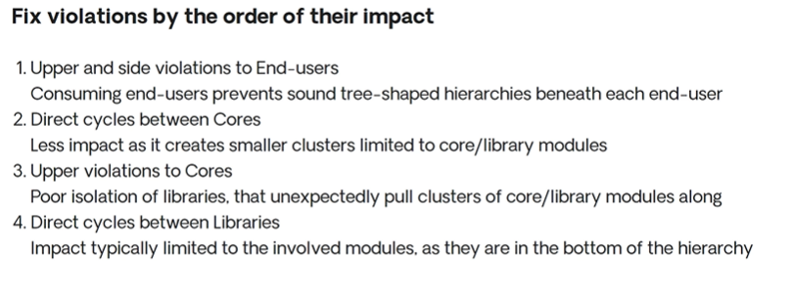

One effective approach is to encourage loosely coupled patterns. To achieve this, avoid upward references such as a library module referencing an end-user screen.

### ****8. Handling Navigation and Dependencies****

Screen destinations can cause reference violations. Use external URLs instead to enable navigation between end-user modules without creating these references. Another case is reacting to business events—such as when customer attributes affect contracts. This can lead to circular dependencies.  
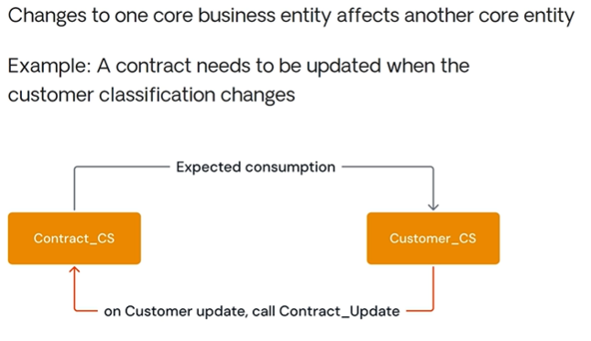

### ****9. Breaking Cycles with Logic Layers****

To prevent this, add a business logic module on top of the core services. This way, changes like updating a customer and then a contract are done sequentially without tight coupling. However, this increases module size and complexity, so explore alternatives.

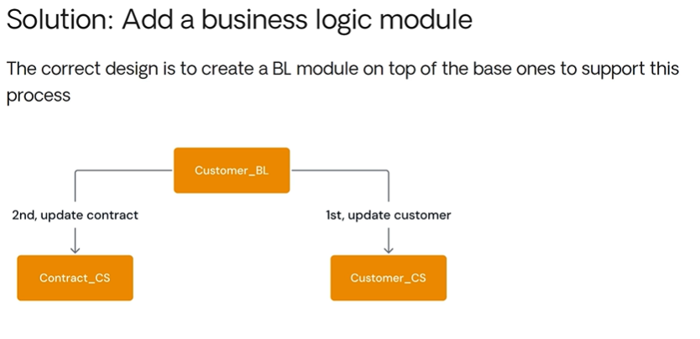

### ****10. Alternatives: REST/SOAP or BPT****

Two alternatives include using REST/SOAP web services or Business Process Technology (BPT). Services remove physical dependencies, though conceptual ones remain. BPT enables asynchronous communication but may have transactional delays.

### ****11. Moving Entities and Data Migration****

Refactoring may involve moving entities, which can cause data loss if not handled properly. The Refactor component on the OutSystems Forge provides migration templates to move elements safely without data loss. It works by linking new entities to original tables.

### ****12. What Refactor Component Supports****

Refactor also preserves roles, site properties, and foreign keys. Actions, screens, and web blocks don’t require explicit declarations in Refactor. Detailed instructions are available in the Forge.

### ****13. Refactor Execution****

Refactor changes don’t take effect until deployed. Developers can apply changes incrementally by republishing only the updated parts of the Refactor module.  
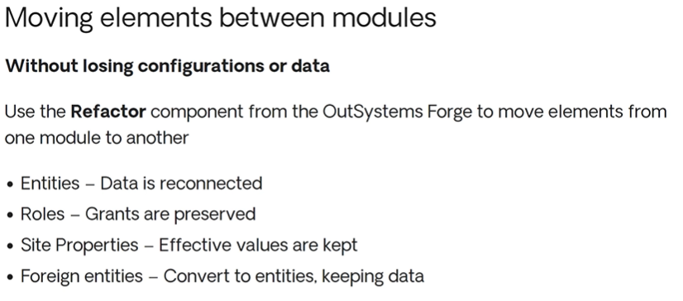

### ****14. Extracting Without Breaking Consumers****

Sometimes, we need to extract elements from consumed modules. This requires maintaining references and involves a seven-step migration process. We’ll explore that in the next session.  
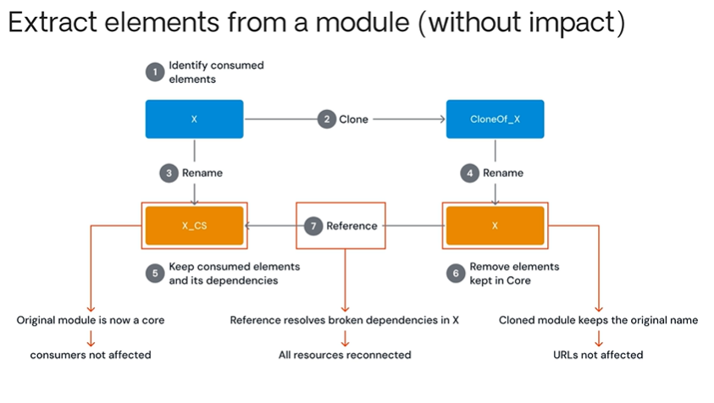

### ****15. Recap****

We started with prioritization criteria and how to decide which violations to fix first. We also discussed scenarios requiring loose coupling and design pattern adjustments. Refactoring isn't just fixing things—it can be about improving architecture.

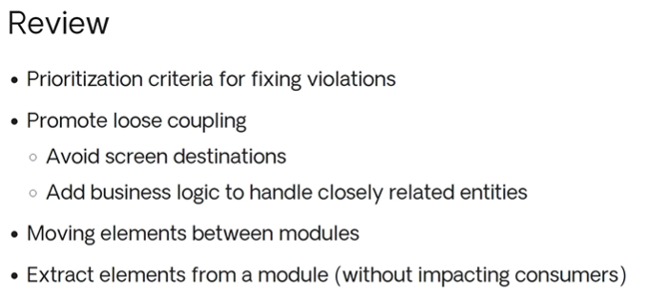

### ****16. Conclusion****

Sometimes, refactoring is simple—like moving a few elements. Other times, it's more complex and requires tools like Refactor and careful planning. That's it for refactoring an application. Thanks for listening!

Extracting Elements  
  
Welcome to this session on Extracting Elements Without Impacting Consumers!

In this session, we’ll dive into a key refactoring technique:

Extracting elements from a module while keeping everything running smoothly for the modules that rely on it.

The goal?

To break things apart without causing any disruptions.

We’ll start by looking at the big picture — getting a clear, high-level view of the process.

Then, we’ll break it down step by step, examining each phase in detail.

Along the way, we’ll walk through a specific scenario to see this technique in action.

And by the end, we’ll explore other situations where this approach can be useful.

So, let’s jump in and get started!

So, when we think about extracting a service without impacting consumers, the most common scenario we’ll run into is this - We have an end-user module, let’s call it X. X contains the expected end-user elements, but it also includes other components that are being reused by different modules.

Some of these might be used by other end-user modules, an orchestration module, or even a core module.

The key here is identifying those shared elements.

Our goal is to refactor and extract them from this module so that we eliminate sideways and upward dependencies, keeping everything clean and modular.

To do that, we'll first create a clone of our original module X. So now, we'll have two copies — our original module X and its duplicate, Clone of X.

With these two duplicate copies, the first thing we want to do is take the first one, rename it, and call it X_CS, which stands for Core Service.

We’re naming it this way because this module will contain all the key elements we’ll be working with.

Now, let’s move on to our duplicate clone and we're going to rename X and give it the name of the original module.

The reason we do this is to ensure that any end-user components, like screens—continue to work without breaking any URLs.

Basically, we'll have two versions of the original module:

The new copy, now called X and the original copy, which has _CS (for core service) added to its name.

Next, we need to jump into this module and keep only the elements that are actually being used, along with their dependencies.

Basically, we'll go in, remove all the end-user elements, and keep just the reusable service.

We'll switch over to our duplicate copy, which we've named X, and do the opposite, removing all the consumed components and core service elements while keeping only the end-user modules and elements.

But here's the catch: this creates a problem because this module actually depends on some of those consumed services, and now they're gone.

As a result, True Change will throw an error.

What we can do is create a reference to the new core service module that’s been set up.

This way, both components will stay consistent and work just fine.

Essentially, we took a bulky module, one that either got too big or accidentally started exposing reusable elements, and split it into two.

But the best part?

We did it in a way that doesn’t impact any consumers or end-users accessing the screen.

Now, I know I went through those seven steps pretty quickly.

We’re going to break it down step by step, with clearer visuals to make everything easier to understand.  
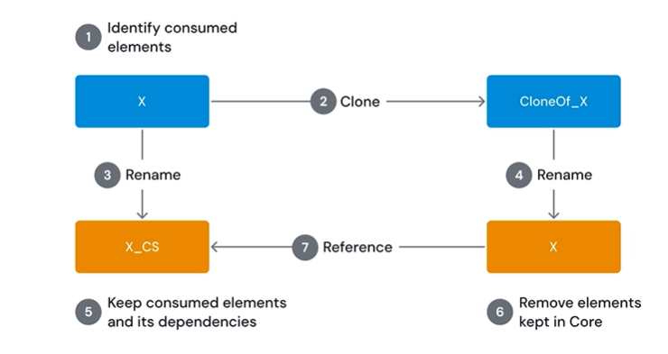

First, we asked ourselves what did we do in the first step?

Well, we set out to identify the consumed elements.

To do that, we took a look inside Module X. As expected, we found some end-user components, but we also came across something that looked more like a service being consumed.

So, we identified which elements were being used and realized we needed to extract them and refactor them into their own module.

The second step is to clone this module.

Once we do that, we get an exact copy of X. Over here, you can see the end-user components, elements, and the consumed elements.

Now, we have two identical copies, just like we talked about earlier—they’re clones of each other.

So, the third step is renaming our original module X to X Core Service.

If we go ahead and make that change, we now have X Core Service, and the original module no longer exists separately, it’s just been renamed.

The key takeaway here is that the original module is now considered a core module.

It still contains the same consumed elements, so anyone using these elements won’t run into any errors.

The renaming only changes the module's name—it doesn’t impact the elements inside.

So, the fourth step was to rename the clone and give it the original name, which was X. Essentially, when we rename the clone of X back to X, we’re left with just X and X_cs4_core_service.

Our clone module takes on the original module’s name, which ensures that our URLs remain unaffected.

In step 5, we’re keeping only the consumed elements in the new X_core_service and removing everything else.

Essentially, we’re stripping out the unnecessary UI elements because this is becoming a core service.

Once we do that, it’s no longer an end-user module, it won’t have any UI elements at all, just the core functionality.

So, when we place it on the canvas, it should be a yellow core service module.

We've already updated the color, so now it's time for step six.

Head over to our cloned version with the original name and delete everything except the elements we kept in the core service.

Basically, all we need in this module are the end-user elements.

Removing the consumed elements won’t cause any issues, it won’t change how the module is displayed.

However, since the end-user modules reference those consumed elements, deleting them will trigger an error, letting us know there’s a problem.

But fixing this issue is actually pretty straightforward.

All we need to do is create a reference for X so it can reconnect with the consumed elements.

Once we set up that reference, these two modules will still provide the exact same components, but now we've separated out the core service so it can be used by other modules as well—not just these two.

This reference takes care of all the broken dependencies in X, and everything is seamlessly reconnected without any issues.

So basically, this gives us a really detailed, step-by-step breakdown of the whole process.

To sum it up, first, we identify the consumed elements.

Then, we make a clone to create a duplicate copy.

We rename one version to serve as the core service, and the other becomes the original for the user interface.

Next, we clean things up, removing anything unnecessary from the core service and the end-user module.

Finally, we link everything back together so that we have exactly what we need.

At a high level, that’s the big picture of how it all comes together!

We started with a module that contained two main elements, and through our seven-step process, we broke it down into two separate modules, where the end user only interacts with the consumed components.

It took us several steps to get here, but essentially, we analyzed the elements, split them up, and placed them into separate modules.

Now, one of them functions as a highly reusable service—because we want to keep reusable services out of the end-user module.

So, in a nutshell, that’s what we did.

One important thing to keep in mind is that people sometimes get caught up in thinking, ‘Oh, there's a seven-step process, and we always need to separate the end-user component from the consumed component.’

But the reality is, things aren’t always that straightforward.

There are many different scenarios that can come into play.

That’s why we named this module the way we did because extracting elements isn’t always a clean-cut process.

Sometimes, a module doesn’t just have end-user capabilities and consumed elements; instead, there are two completely different sets of consumed elements, each serving different types of modules and consumers.

So in this case, we might follow a similar set of steps—probably more than seven—to extract all the necessary pieces.

What we’d likely do is take consumed one and place it inside a core service module, while consumed two might go into a different core service module.

Then, we’d keep our end-user elements within the end-user module.

In this setup, the end-user module might need some elements from consumed one, but it wouldn’t actually use anything from consumed two.

Sometimes, when you're refactoring, you realize that more than one set of elements is being used—not just the ones from the original module.

In this case, you might find two separate elements being consumed by different consumers.

It wouldn’t make sense to group them into the same module because those consumers may have different life cycles, and their components might change at different rates.

So, it's not always just one service being used.

That's one scenario to consider.  
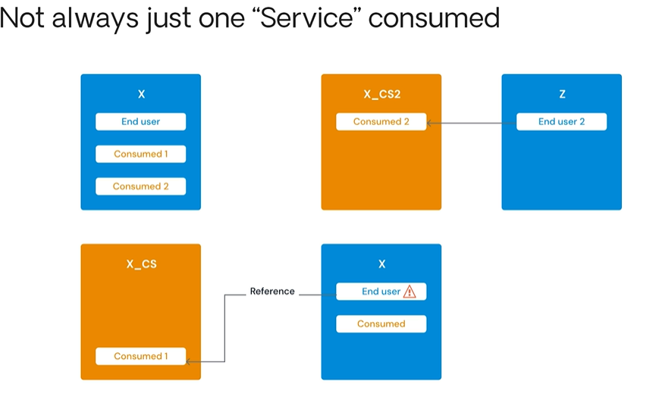

Another scenario is that while we've been focusing on end-user and core services, they're not the only types of modules or layers where this could happen.

What if we started with a core service and discovered a reusable service within it?

But in this case, that reusable service was purely a technical component, it didn’t have any business logic or concepts.

So, it was more of a technical building block.

Now, we could refactor that core service out of the library and apply the same approach.

In fact, this kind of scenario happens from time to time.

It’s actually a bit easier to refactor because we can create a clone without worrying too much about naming conventions, since we’re not trying to maintain a specific URL for end users.

This is a valid approach, and we can leverage the same refactoring technique to solve this problem efficiently.  
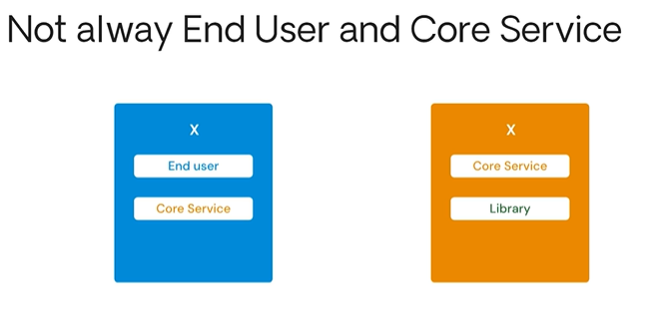

To wrap things up, in this session, we covered how to extract elements without impacting the consumer.

We walked through it step by step and explored different scenarios that might come up.

Hopefully, this gives you a solid foundation for refactoring and makes it easier to create well-structured modules and architectures moving forward.

And that's everything we have for you about Extracting Elements!

Thank you for watching.  
  
  
*************************************